Heather Primary School –
Homework Booklet

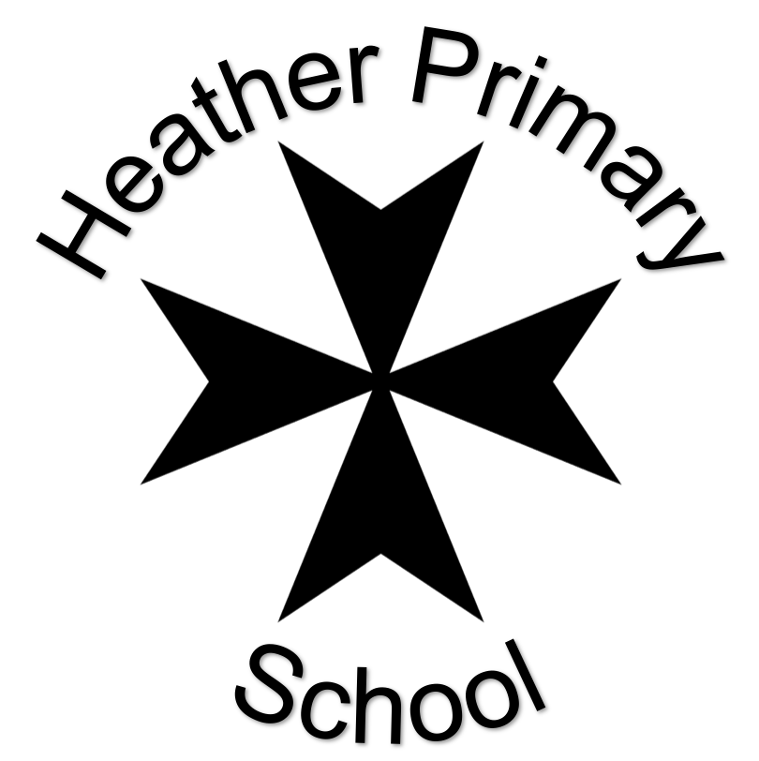

Summer 2022
Class: Ladybird Class – Year 1/2

 | Task | Set | Due
 | Choose an activity from the list below. | Friday 29th April | Monday 9th May
 | Choose an activity from the list below. | Monday 16th May | Monday 6th June
 | Choose an activity from the list below. | Monday 13th June | Friday 27th June

Choices
English
In our English lessons, we are learning the text At the Beach, which is based on characters in the story sending postcards.  Write a postcard/postcards from places you have visited, e.g. Sence Valley, the beach or a trip to the farm. Remember to include lots of detail through using interesting adjectives!  Please see attached template if you would like to use this, or you can create your own. | You are a restaurant owner who has been hired to cater a beach picnic. Create a beach-themed summer menu for the party guests. Include each of the following on your menu: Starter Main Course and Dessert.  Challenge- can you use only items you might find at the seashore. Give each dish a descriptive name, such as “Mixed Seaweed Salad in Clam Shells.” | At a beachside souvenir shop, you buy a beautiful golden shell. As you polish the shell to remove some of the sand, a genie suddenly pops out to grant you three wishes! His only condition is that each wish must bless someone other than you. Who will benefit from your wishes? Explain what you will wish for, and why.
Maths
Practise writing numbers (up to 3 digits) in your sandpit or soil at home with a small stick or shell. Read the numbers you write aloud to an adult. You may like to take a photograph and stick it in your book for us to see. | We have been learning about money in maths. Create your own toy shop, making a price label for each of your toys up to £1.00. Invite members of your family to visit your shop and buy your toys. You will need to add up the amounts and record in your homework book. Remember to show what coins they use to pay for each item. | Year 1:  Find an interesting way to represent number bonds to 20, e.g. 15 teddies and 5 dolls. Show all of the number bonds to 20. | Year 2:  Find an interesting way to learn and represent your 3 times table.
Other Subjects
Geography  Research plants which only grow in particular climates around the world. | Science  Food from plants - Why are plants so important to humans? Research which foods we get from plants. Consider different parts of plants which can be eaten for example seeds - peas, bulbs - onions, leaves – cabbage and stems – celery. | Art/ DT  Research the artist Giuseppe Archimboldo.  Create a portrait using real fruits and vegetables. Take a photograph and present it in your book.

