Learning Project Week 7: The UK!
Class: Donaldson
Please complete at least 3 of the tasks below during the week:
We love to see what you are doing on our private Facebook Page or Twitter Feed: www.facebook.com/groups/heatherprimaryschoolcoalville
@HeatherPrimary
Weekly Maths Tasks | Weekly Reading Tasks
- Participate in the daily maths lesson from the government’s home learning website: Government Home Learning Website.  - Continue working on Numbots  - Sing a range of number songs, such as ‘5 Currant Buns’ and ‘5 Little Ducks’.  - This week, work on some addition. Generate your own addition number stories: First, there are 3 people on the bus. Then, 2 more people get on the bus. How many people are on the bus?  There are 4 shells on your sandcastle. You add one more shell. How many shells are there now?  - Ask your child to make 10 using different objects from around the house/garden e.g. dry pasta. You could challenge them by giving them a small quantity to begin with, e.g. 4 pieces of dry pasta, and children have to count on to work out how many more pieces are needed to make 10. | - Read a variety of books at home. Favourites can be repeated. Hearing the patterns of language in a story will support your child’s language development.  - Children to practise their tricky word flashcards regularly.  - Children to read to parents daily. Visit Oxford Owl for free eBooks that link to your child’s book band. You can create a free account. Complete the linked play activities for each book.  - Read ‘Oliver’s Vegetables’: https://www.youtube.com/watch?v=IhmqiEXe8dc  - Have you ever grown any vegetables? What have you grown? Did you taste them? How did they taste?  - Participate in daily phonics lessons 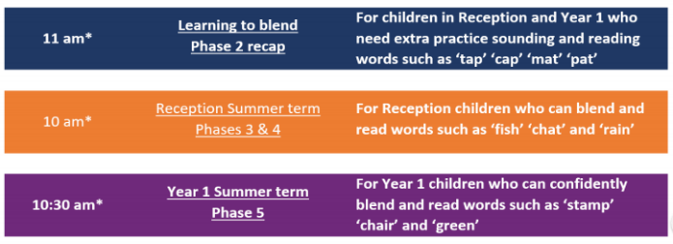
Weekly Phonics Tasks | Weekly Writing Tasks
- Sing Nursery Rhymes and songs. Repeat old favourites and learn new rhymes. You can find an A-Z of Nursery Rhymes here.  - Daily phonics - Practise the sounds in your child’s phonics book and blend to read words containing some of these sounds, e.g. b-oa-t. This can be oral blending (e.g. spoken out loud b-oa-t) or written if appropriate. Find some interactive games on www.phonicsplay.co.uk and Top Marks.  - Spelling Shed | - Practise forming the letters of the alphabet.  - Ask your child to write out some of the tricky words they are working on at the moment (from their tricky word flashcards) on pieces of paper and turn them into a pairs game. You could work on a few each day, e.g. write out ‘I’, ‘go’ and ‘no’ twice, turn them over, and see if they can find the matching pairs.  - Thinking about the story ‘Oliver’s Vegetables’, draw a picture of your favourite type of vegetable or a vegetable you have grown. Can you label it? If you like lots of vegetables, you can draw and label them all.  - You could write a letter or card to a friend or a family member who lives in a different part of the UK - describe where they live. You could ask them questions about what is like where they live.
Learning Project – ongoing throughout the week: The UK!
Choose from the selection below:
The projects this week aim to provide opportunities for children to learn more about the country they live in.
Make a UK Flag:
Which countries make up the UK? Learn about the UK flag and look at the colours. Find a Union Jack template online or draw one and children paint or clour in the flag to decorate. They could add a straw on lollipop stick, so that they can wave their flag.

Where do your family come from?
Discuss with your child where different members of your family come from. Do they all come from the UK? If you have them available, show your child photographs of where you, or their grandparents, grew up. This might be similar to where they live now or completely different. Encourage your child to think about the differences between the places.

Holidays in the UK:
Have you ever been on holiday in the UK? Which places did you visit? You could make a booklet about a holiday you have been on in the UK, label the places and write a sentence about what you enjoyed, or you could paint a picture of a beach you have visited in the UK.

Get building:
Find out about famous landmarks in the UK. You could make one of the landmarks you discover using junk modelling resources or construction pieces, e.g. Lego.
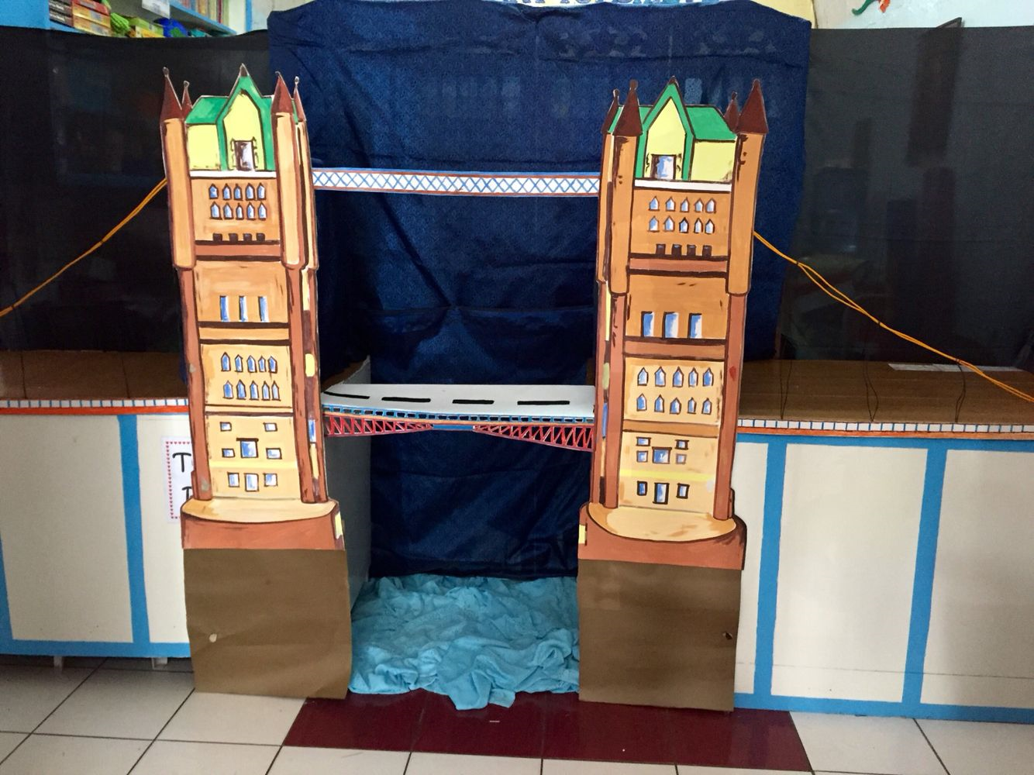

UK Cuisine:
Find out about traditional UK food. You could have a go at doing some baking or draw and label a picture of your favourite food from the UK.

Music – Log on to Chrome Music lab:
https://musiclab.chromeexperiments.com/Song-Maker/

PE:
Complete the daily task from the NWLSSP power point (sent on Weduc daily).

