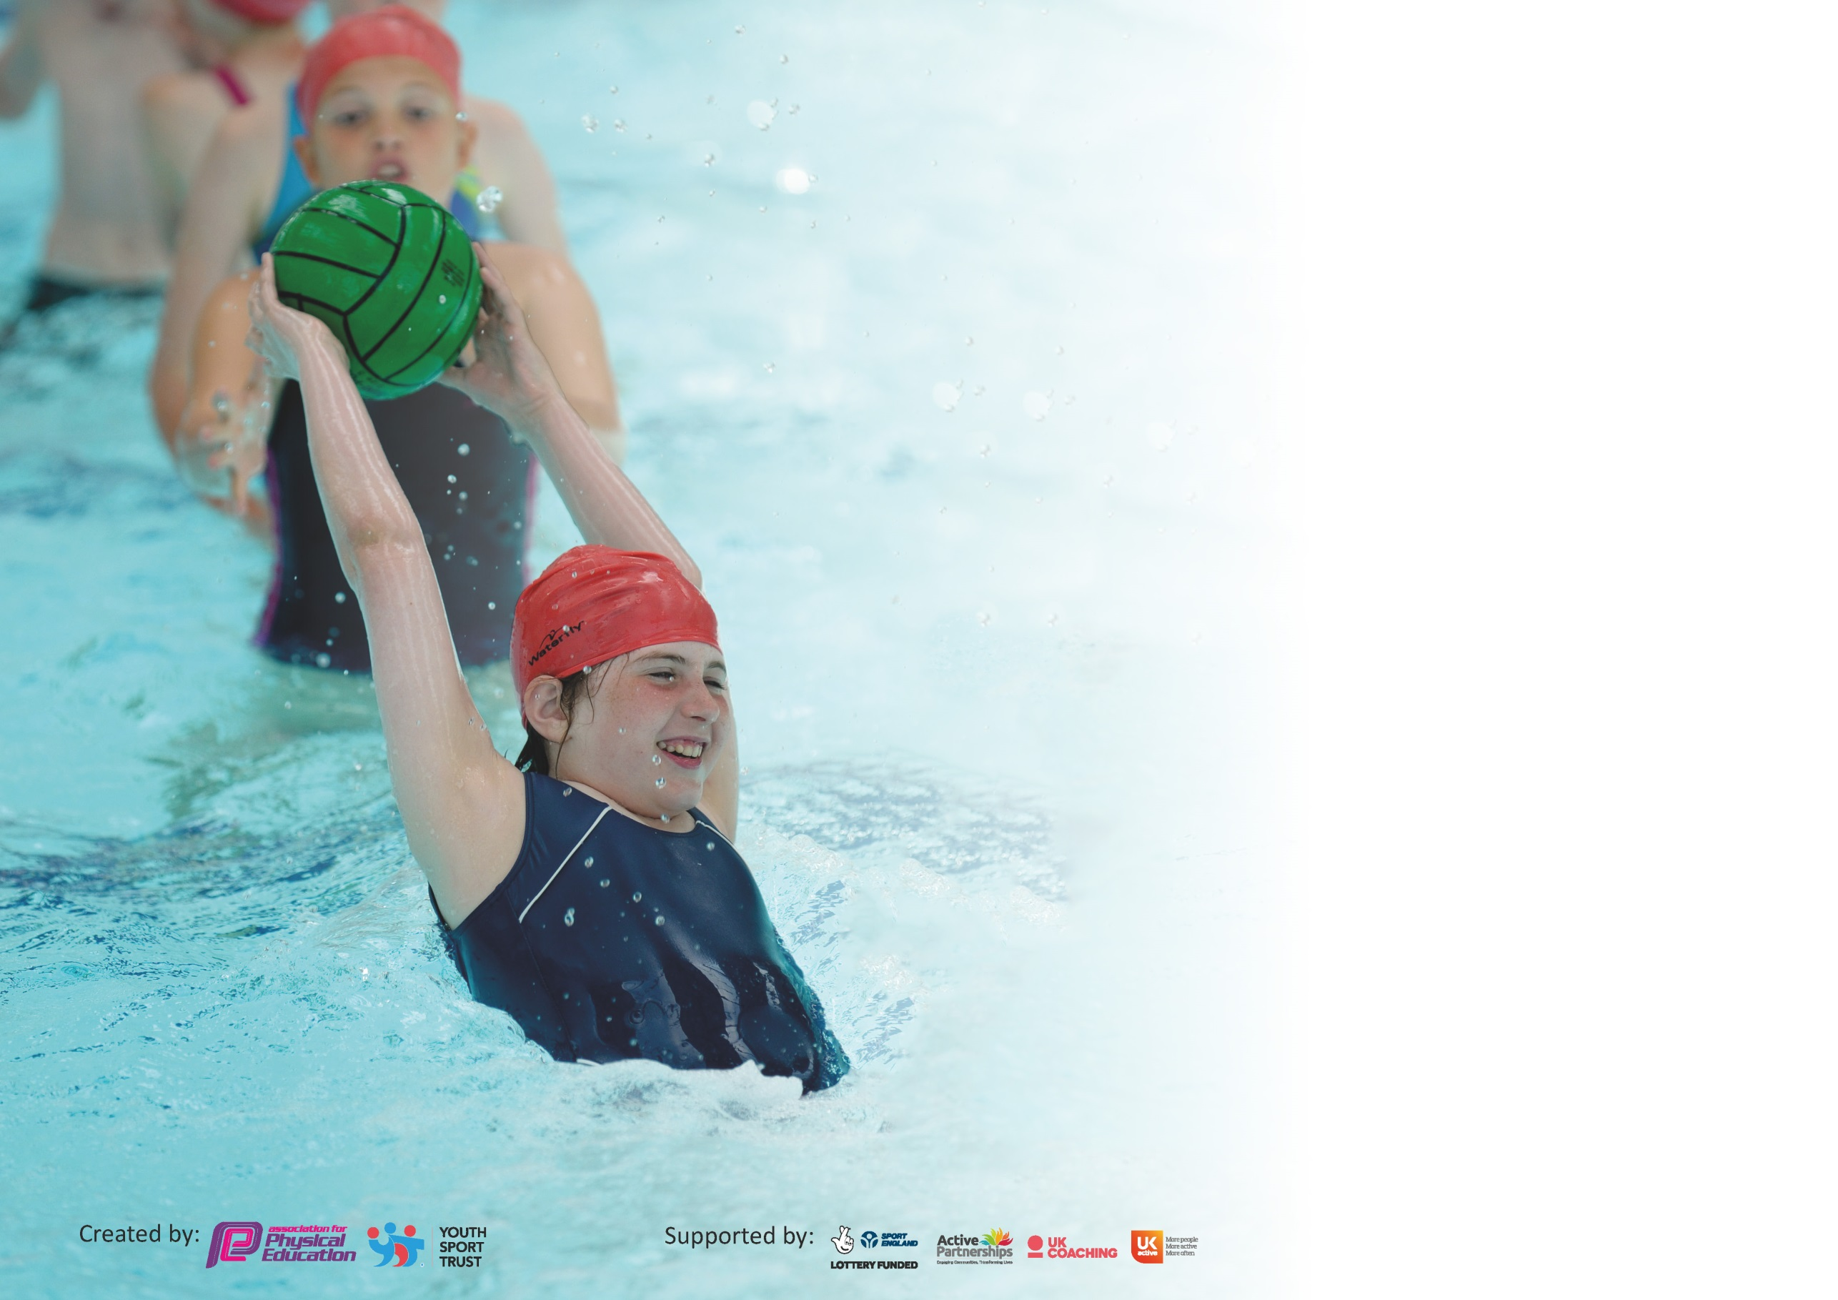

It is important that your grant is used effectively and based on school need. The Education Inspection Framework (Ofsted 2019 p64) makes clear there will be a focus on ‘whether leaders and those responsible for governors all understand their respective roles and perform these in a way that enhances the effectiveness of the school’.

Under the Quality of Education criteria (p41) inspectors consider the extent to which schools can articulate their curriculum (INTENT), construct their curriculum (IMPLEMENTATION) and demonstrate the outcomes which result (IMPACT).

To assist schools with common transferable language this template has been developed to utilise the same three headings which should make your plans easily transferable between working documents.

Schools must use the funding to make additional and sustainable improvements to the quality of Physical Education, School Sport and Physical Activity (PESSPA) they offer. This means that you should
use the Primary PE and Sport Premium to:

- Develop or add to the PESSPA activities that your school already offer
- Build capacity and capability within the school to ensure that improvements made now will benefit pupils joining the school in future years

Please visit gov.uk for the revised DfE guidance including the 5 key indicators across which schools should demonstrate an improvement. This document will help you to review your provision and to report your spend. DfE encourages schools to use this template as an effective way of meeting the reporting requirements of the Primary PE and Sport Premium.

We recommend you start by reflecting on the impact of current provision and reviewing the previous spend.

Schools are required to publish details of how they spend this funding as well as on the impact it has on pupils’ PE and sport participation and attainment by the end of the summer term or by 31st July 2020 at the latest.

We recommend regularly updating the table and publishing it on your website throughout the year. This evidences your ongoing self-evaluation of how you are using the funding to secure maximum, sustainable impact. Final copy must be posted on your website by the end of the academic year and no later than the 31st July 2020. To see an example of how to complete the table please click HERE.

Support for review and reflection - considering the 5 key indicators from DfE, what development needs are a priority for your setting and your pupils now and why? Use the space below to reflect on previous spend and key achievements and areas for development.

Key achievements to date until July 2019: | Areas for further improvement and baseline evidence of need:
- CPD to continue through weekly coaching sessions delivered to every class by outsourced specialist coaches where teacher observes weekly and then delivers sessions under the supervision of the coach.  - The provision of broader after school club provision to engage wider group of pupils including provision for key stage 1.  - A carefully planned long term plan which incorporates preparation through weekly PE sessions and specific coaching in preparation for level 1 and 2 competitions. | - To develop a robust tracking system for progress in curriculum PE in all year groups. Inset planned for spring 2020. Unfortunately, this did not go ahead due to school closure. Re booked for the autumn term 2020.  - To further training and delivery of quality lunchtime activities which engage all pupils. CPD with lunchtime staff and work with play coaches and bronze ambassadors  - To continue to offer key stage one after school clubs.  - To embed road safety week into school programme (Summer 2020) Unfortunately this did not happen due to COVID 19 school closure. (this will be move to next year).

Meeting national curriculum requirements for swimming and water safety.
What percentage of your current Year 6 cohort swim competently, confidently and proficiently over a distance of at least 25 metres?  N.B. Even though your pupils may swim in another year please report on their attainment on leaving  primary school at the end of the summer term 2020. | % Data to be collected after swimming sessions running through the spring term for year 3,4,5,6,
What percentage of your current Year 6 cohort use a range of strokes effectively [for example, front crawl, backstroke and breaststroke]? | % Unfortunately, due to COVID 19 school closure Swimming sessions were not completed and data not  Finalised.
What percentage of your current Year 6 cohort perform safe self-rescue in different water-based situations? | % N/A
Schools can choose to use the Primary PE and Sport Premium to provide additional provision for swimming but this must be for activity over and above the national curriculum requirements. Have you used it in this way? | No

Action Plan and Budget Tracking
Capture your intended annual spend against the 5 key indicators. Clarify the success criteria and evidence of impact that you intend to measure to evaluate for pupils today and for the future.

Academic Year: 2019/20 | Total fund allocated: £ 16926 | Date Updated: July 20
Key indicator 1: The engagement of all pupils in regular physical activity – Chief Medical Officer guidelines recommend that primary school pupils undertake at least 30 minutes of physical activity a day in school |  |  |  | Percentage of total allocation:
 |  |  |  | 5%
Intent | Implementation |  | Impact
Your school focus should be clear what you want the pupils to know and be able to do and about  what they need to learn and to  consolidate through practice: | Make sure your actions to achieve are linked to your intentions: | Funding allocated: | Evidence of impact: what do pupils now know and what can they now do? What has changed? | Sustainability and suggested next steps:
All children signed up to the club active 8 scheme ran by ‘Everyone Active’ giving children the opportunity to use points accumulated through school  activities.  Continued work with lunchtime supervisors to develop lunchtime activities in collaboration with play coaches and bronze ambassadors.  Lunchtime supervisors to receive half hourly sessions with Mr PE, Autumn 1 (6 weeks) CPD.  Lunchtime supervisor training with Jenny Mosely  Lunchtime Supervisor online training (during COVID 19 lockdown  Half hour weekly coach available during lunchtime to run a specific club for targeted group.  Lunchtime supervisors to work with play coaches to deliver activities/games  Provide lunchtime specific equipment  Bronze Ambassador training for 2x year 5 and 2x year 6 pupils  Mindfulness and wellbeing- daily videos used to enhance pupil wellbeing and to encourage physical activity as a means of keeping a healthy body and mind. | Yes  Regular half termly meetings with lunchtime supervisors to discuss the development of lunchtime activities with head teacher and PE coordinator.  To improve lunchtime supervisor engagement with active 60 minutes per day for each child, lunchtime activities to play a key role in this.  All year 5 and 6 children to receive play coach training in the autumn term.  Equipment to be purchased for social distanced activities at lunchtime  Bronze Ambassadors work with PE co Ordinator and PE coaches to deliver one intra-school competition per term  10 min Daily videos available for all year groups in school in Summer 2 following COVID lockdown. | £1.50 per pupil sign-up fee x 116 POR  £174.00  £260.00  £76.00  See collective costing for coaches below  Training included in NWLSSP buy in option  £168.62  Training included in NWLSSP buy in option  £147.00 | Data to be obtained from active 8 on how much the children have used their accumulated points; however, this will be difficult as all local leisure centres closed for the lockdown and still remain closed so pupils are unable to spend their accumulated points on activities.  Improved confidence of lunchtime supervisors to engage with pupils in activities at lunchtime  Christmas in school festival was organised and delivered by bronze ambassadors for all classes. This was well received by all classes and run well by the ambassadors.  Children in school during lockdown have been able to engage in activities in a safe way  Year 5 and 6 pupils work on a lunchtime playground rota voluntarily, helping the lunchtime supervisors to deliver games and activities.  Children have engaged positively with the videos | Once data has been analysed, decide whether or not to continue with the scheme in 20/21.  If continuing then plan an assembly or class delivery to promote the scheme and send information home to families making them aware of the scheme and its benefits  To continue in Autumn 2020  To continue one lunchtime per week in Autumn 2020  Unfortunately, due to lockdown we were unable to deliver any more intra- school competitions.  We will carry this forward to next term.  To continue to use these resources at lunchtimes.  Next years 5 and 6 to receive the play coach training and the new year 5 pupils will be offered the opportunity to join the play coach rota.  Assess impact with staff and pupils in autumn term and decide whether to continue
Key indicator 2: The profile of PESSPA being raised across the school as a tool for whole school improvement |  |  |  | Percentage of total allocation:
 |  |  |  | 25%
Intent | Implementation |  | Impact
Your school focus should be clear what you want the pupils to know and be able to do and about  what they need to learn and to  consolidate through practice: | Make sure your actions to achieve are linked to your intentions: | Funding allocated: | Evidence of impact: what do pupils now know and what can they now do? What has changed? | Sustainability and suggested next steps:
To continue to engage with wider sporting community thorough membership of NWLSSP  To use PE co Ordinator directed time to develop a broad PE curriculum and lead CPD.  Quality teaching and learning for curriculum PE- full academic year up to and including year 6  Upskill and mentor staff/team teach  Leicester Riders Basketball Key Stage two  Bhangra Blaze dance workshop for all pupils  Sam Shipman – Cricket coaching  Key Stage One road safety sessions delivered  Bike ability training for Key Stage 1 & equipment | Buy in to NWLSSP Option 2-Access to CPD, competitions, festivals  Curriculum Development time in school  External specialist PE brought in to curriculum PE to support implementation of new scheme of work. (Mr PE) as a block of delivery, team teaching is actively encouraged. Also Coach unlimited, Leics Riders, Skipping Henry, Bhangra Blaze  External provider  Workshop in school delivered to all classes.  Booked in.  Delivered by Coach unlimited  External training | £2965.00  £230.00  See collective costing for coaches below  Collective costing  Not delivered due to COVID  £180.00  £800 | A broader PE curriculum delivered to all classes.  Enhanced levels of participation throughout KS Time used to develop medium term plans.  All key stage two children received basketball sessions through the autumn term.  Positive impact, all children really enjoyed the sessions.  This was scheduled for the summer term but didn’t go ahead due to Covid 19.  Well received.  Weekly sessions led by EYFS teacher have been successful. These are to continue. | Buy in option 2 planned for 2020/2021  To continue to ‘buy in’ coaches to act as CPD for staff.  They have been contacted for coming into school next academic year.  This has been priced and planned with Coach Unlimited for Autumn 2020  I would like more bike ability sessions run in Year 1 with children by TA who has attended the training acting as a lead in Autumn 2020

Key indicator 3: Increased confidence, knowledge and skills of all staff in teaching PE and sport |  |  |  | Percentage of total allocation:
 |  |  |  | 34%
Intent | Implementation |  | Impact
Your school focus should be clear | Make sure your actions to | Funding | Evidence of impact: what do | Sustainability and suggested
what you want the pupils to know | achieve are linked to your | allocated: | pupils now know and what | next steps:
and be able to do and about | intentions: |  | can they now do? What has
what they need to learn and to |  |  | changed?
consolidate through practice:
To continue provision during weekly PE sessions of quality coaching for all year groups in all curriculum areas, this is also weekly CPD for teaching staff. | Coach Unlimited and Mr PE have been booked for next academic year. Each class will receive at least one PE session per week with a coach which will be their CPD | £5032.25  Mr PE  Coach Unlimited  Leicester Riders  Sam Shipman  Skipping Henry  Bhangra Blaze | Pupils have become more confident and competent in areas of the curriculum. Participation in level 1 and 2 competition now readily engaged in. | To continue with coaching provision in 20/21 now that funding has been confirmed
Key indicator 4: Broader experience of a range of sports and activities offered to all pupils |  |  |  | Percentage of total allocation:
 |  |  |  | 0%
Intent | Implementation |  | Impact
Your school focus should be clear | Make sure your actions to | Funding | Evidence of impact: what do | Sustainability and suggested
what you want the pupils to know | achieve are linked to your | allocated: | pupils now know and what | next steps:
and be able to do and about | intentions: |  | can they now do? What has
what they need to learn and to |  |  | changed?
consolidate through practice:
Additional achievements:  After school sports clubs available to both Key stages across the school, increased participation – see registers | A variety of clubs have been run this year up until March 10th which include:  Football, netball, gymnastics,  Children have attended cross county races at weekends competing against other local schools. | Funding for coach unlimited to run an afterschool club and for Mr PE to run a targeted lunchtime club.  See above collective costing | An effort has been made to engage the less active groups at lunchtimes and after school. | Although at times this can feel an uphill struggle, the plan is to continue to run targeted groups at lunchtime and after school.

Key indicator 5: Increased participation in competitive sport |  |  |  | Percentage of total allocation:
 |  |  |  | 14 %
Intent | Implementation |  | Impact
Your school focus should be clear | Make sure your actions to | Funding | Evidence of impact: what do | Sustainability and suggested
what you want the pupils to know | achieve are linked to your | allocated: | pupils now know and what | next steps:
and be able to do and about | intentions: |  | can they now do? What has
what they need to learn and to |  |  | changed?
consolidate through practice:
Resources: Purchase resources to support the delivery of curriculum PE and after school activities and enhance experience in sessions.  To ensure all children have equal opportunity to be able to participate in out of school competitive sport and festivals  SEND Leicestershire Disability Athletics Development Group. | Audit school resources then purchase necessary resources identified as required to deliver activities.  Provide transport to and from events for all pupils.  Access for SEND pupils | £1072.50  Funding  allocated to resources/equipment to support Curriculum delivery and participation for all.  Transport  £1220.00  Allocation of funds for coaches and taxis (see budget sheet)  £25.00 | New resources have allowed pupils to experience a wider variety of sporting activities.  This allows more children to take part who otherwise would not due to transport restrictions.  Inclusive sport opportunity for SEND | Continue to replace resources where necessary, when damaged or worn out.  To purchase school archery set as an alternative sport which can be offered to inactive children at lunchtime.  Continue to provide this.  Find ways to encourage children to take part in competitions and events that go beyond the school day.  Not planned for next academic year.

Signed off by
Head Teacher: | Maxine Michalowski
Date: | 30th July 2020
Subject Leader: | L Thornley
Date: | 10.7.20
Governor:
Date: | 18th August 2020

