Heather Primary School

Prospectus 2021/22

Contact Details

Main Street
Heather
Leicestershire
LE67 2QP
Tel 01530 260257
Email adminoffice@heather.leics.sch.uk
Head teacher Mrs Maxine Michalowski
Chair of Governor Mr Andrew Smith
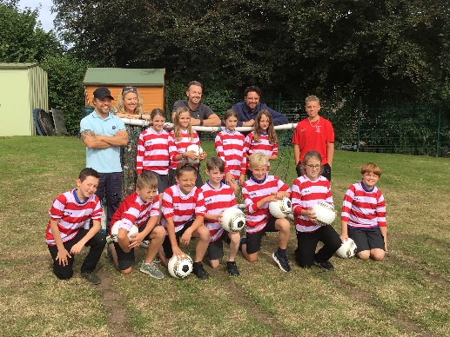
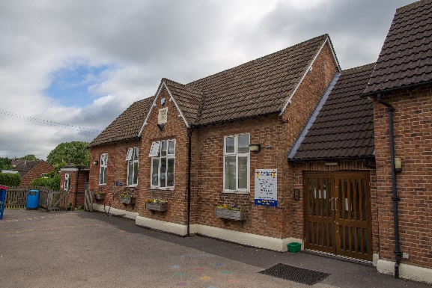

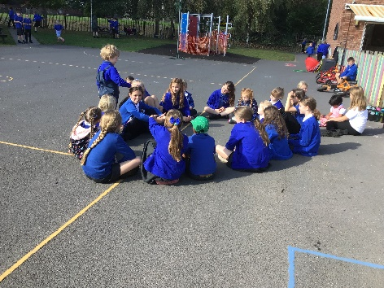
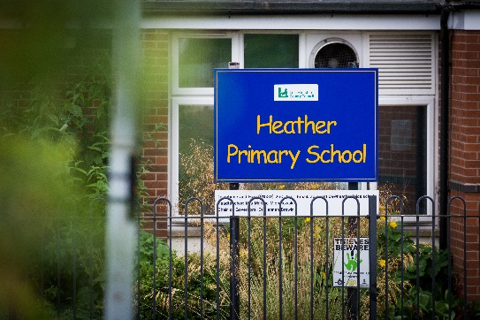

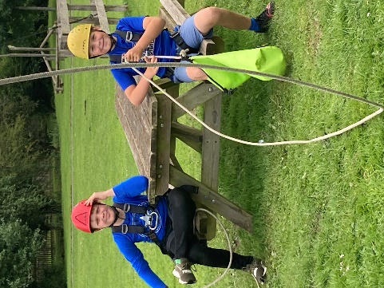
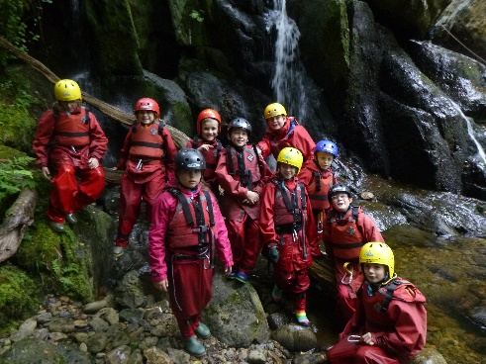

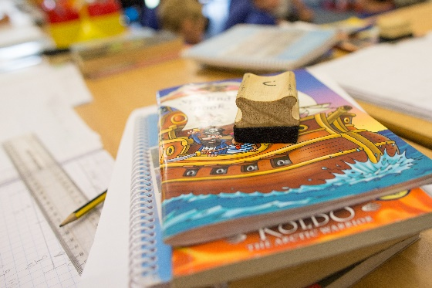
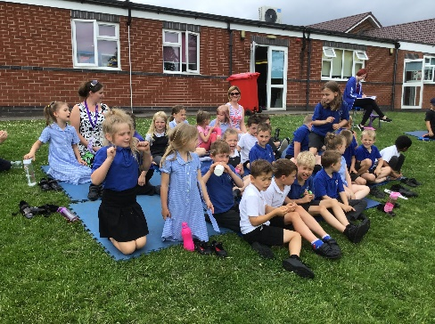

Welcome

Welcome to Heather Primary School. We are a small village primary school in North West Leicestershire for pupils age 4 –11.

Our Vision
At Heather Primary School, our vision is to inspire each child to become a well-motivated and independent learner who will utilise these skills through the rest of their school and adult lives.
Our Aims
At Heather Primary School we aim to:
- Ensure that our children enjoy life-long learning through a rich and varied curriculum, enhancing their creative and imaginative skills.
- Encourage each child to reach their full potential as a valued member of Heather Primary School.
- Provide opportunities for the pupils to develop and make responsible and informed choices about their behaviour and their learning.
- Develop children who are increasingly aware of their local community, the wider world and its cultures.
- Provide children with the opportunities to develop their confidence and skills to be successful in the future.
- Develop children to work both independently and collaboratively throughout all aspects of school life.

What we are proud of

What our children think of our school:
- I like the Daily Mile: my stamina is improving.
- We did a topic on dinosaurs and we made coprolite – now I want to be a palaeontologist.
- I like it when we do sewing – our grown-ups get to come and work with us.
- I have really enjoyed the archery after school club.
- Being Star of the Week makes me feel proud.
- I like listening to other people’s ideas during lesson times.

What our parents and visitors say of our school:

- My two grandchildren attend Heather Primary School and they are extremely happy there.
- After experiencing another school, it has highlighted how great Heather Primary School is.

Our whole school ‘record of achievement’

Healthy Schools Award
Leicestershire Beyond Bullying Award
Sainsbury’s Gold Award for Sport

Ofsted Report
We were classified as good in our last Ofsted inspection in January 2017.
Ofsted said:
- This school continues to be good. The leadership team has maintained the good quality of education in the school since the last inspection.
- Your vision for the school is clear and well communicated.
- You place pupils and their life chances at the centre of the school’s work.
- You also value pupils’ views very highly and work hard to ensure that these views, alongside those of their parents, are listened to and acted upon.
- The school is a calm and welcoming place for pupils to learn.
- Pupils behave well around the school and in lessons.
- Playtimes are enjoyable occasions where pupils socialise and play well with one another.
- Formal gatherings of pupils, such as assemblies, are also enjoyed by pupils because they are given the chance to contribute their thoughts and feelings.

Who is Who at Heather Primary School
Staff List
Mrs Michalowski Headteacher
Mrs Smith Class Teacher
Miss Barton Class Teacher
Mrs Clarkson Class Teacher
Mrs Goode Class Teacher (2 days per week)
Mrs Thornley Class Teacher (3 days per week)
Mr Johnson Class Teacher (Maternity Cover)
Mrs Thornley SENDCo

Mrs Livesey Teaching Assistant
Miss Ralston Nursery Nurse
Mrs Winterton Teaching Assistant
Miss Chappell Teaching Assistant
Mrs Conway Learning Support Assistant
Mrs Andrews Learning Support Assistant
Mrs Harden Learning Support Assistant

Mrs Riley-Lowndes Office Manager

Mrs Brown Premises Officer, Lunchtime Supervisor, Road Crossing Patrol
Mrs Cope Lunchtime Supervisor and Breakfast/After School Club Assistant
Mrs Hill Lunchtime Supervisor and Breakfast/After School Club Assistant
Mrs Ottey Breakfast/After School Club Assistant

Our Governing Body
Chair – Andrew Smith – Co-opted Governor
Vice Chair – Caroline Ludlam – Co-opted Governor
Maxine Michalowski – Headteacher
Dawn Guzzetta – LA Governor Governor
Vacancy – Parent Governor
Vacancy – Parent Governor
Sara Riley-Lowndes – Staff Governor
Nicole Adcock – Parent Governor
Sarah Weedon – Parent Governor
Vacancy – Co-opted Governor
Vacancy – Co-opted Governor

Admissions
The current number on role for Autumn 2021 is 113 children.
We organise our classes in different ways annually to meet the range of needs of our children, some years this will be in single year groups but generally our classes are taught in mixed age classes.
Reception Admissions
Children start school at the beginning of the Autumn term before their fifth birthday. The children who are due to start with us in our Reception (Donaldson) class are invited into school usually in May and June for some ‘Stay and Play’, ‘Drop and Go’ sessions, as well as an induction morning in school which takes place in early July. During the ‘Stay and Play’ sessions, we also run a couple of parent/carer meetings to discuss the school day, uniform etc. as well as discuss any concerns parents/carers may have in how to prepare their child for a smooth transition into school life. Reception children joining us in the Autumn are full-time from the beginning of term.
Mrs Smith, our EYFS teacher, where possible, will visit the children in their current early years setting.

The School Day

Children line up on the playground at 8:45am and are taken into the classroom for the start of the school day.
8:55am – Registration
10:45-11:00am – Break-time
11:50am -1:00pm – Lunch-time for Donaldson
12:00pm-1:00pm – Lunch-time for the rest of school
3:15pm – End of the school day.

Children are collected from the playground at the end of the day by their parents/carers. Each class will be brought out by a member of the school staff and will not be released until they have been collected as arranged. If you are held up on your way to collect your child, please come to the school office to collect them when you arrive.
Please note - For all children, we ask that you notify us of any change to arrangements for collecting them. A phone call is all we need, but as part of our role in safeguarding children throughout the school day, we will keep children with us until they have been collected by the expected adult.

Before and After School Care

Our Breakfast Club starts at 7:30am, where the children are provided with breakfast and can join in with a range of planned activities before the start of school. Children move directly to their classroom from Breakfast club at 8:45am.
After School Club runs from 3:15pm until 6pm (5pm on Fridays). The children are provided with a light meal, and as in the morning, will take part in a range of activities including outdoor play.
Charges are as follows:
Breakfast Club
Drop off between 7:30am -7:59am - £6.50 (breakfast provided)
Drop off between 8:00am – 8:29am - £4.50 (breakfast provided)
Drop off between 8:30am -8:45am - £2.50 (no breakfast)

After School Club
Session 1 3.15pm – 4.15pm £4.50 (Small snack and drink provided)
Session 2 4.15pm – 5.00pm £4.50 (Light meal and drink provided)
Session 3 5.00pm – 5.30pm £2.50
Session 4 5.30pm – 6.00pm £2.50

The second and third child in the family receive a £1 discount per child. Payment requests are issued at the end of each calendar month and we welcome payments by Childcare Vouchers.

Newsletters

We post our monthly newsletters, on the school website – www.heatherprimaryschool.co.uk and Weduc. Currently we send paper copies home to families with the oldest child on the same day.

Complaint procedure to the School/LA

If you have any concerns or questions, we are always glad to see you and to discuss these in a positive and constructive way. It's important to us to be able to work as a team with our parents and families.
In the first instance, it's best to talk with your child's class teacher, but if you feel that this is inappropriate for any reason, or if a discussion with the class teacher hasn't resolved the issue to your satisfaction, please make an appointment to see Mrs Michalowski or a member of the School Leadership Team at a mutually convenient time.
If you are unhappy about the response from the headteacher or SLT, you may wish to speak to a member of the Governing Body, and the School Office can give you contact details for this.
Contact details for the Local Authority are available on the Leicestershire County Council website, or via the School Office. The full Complaints Policy for the school is available on the website or from the school office.

School Uniform
We ask children to wear school uniform, which ensures that the whole school looks smart and helps to give everyone a sense of pride in representing our school. Our uniform is:
- Grey/black trousers/skirt or pinafore dress
- Royal blue/white polo shirts – ones with the school logo on are available from our uniform suppliers
- Royal blue sweatshirt, cardigan or fleece – again available from our uniform suppliers
- In the summer grey/black school shorts (not denim or sports wear) or blue gingham dress/skorts may be worn
- Plain, white/black/grey socks or tights
- Black sensible shoes – no open toes, no heel more than 3 cm

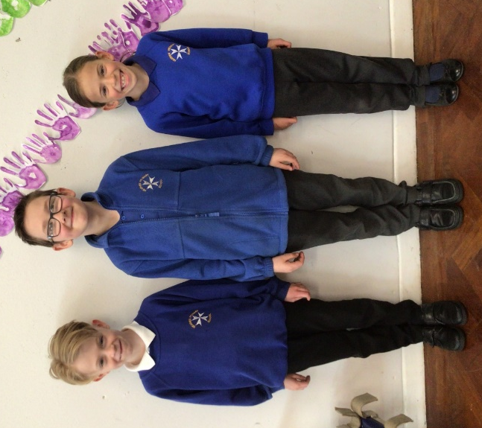
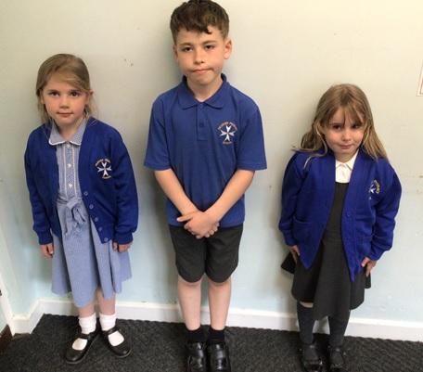

School uniform can be ordered from www.ept-schoolwear.co.uk who are based in Coalville or www.pmgschoolwear.co.uk. Items can be ordered to be delivered direct to you or collected if ordering through EPT. Please allow at least 28 days for delivery at busy times.
We do have some pre-loved uniform in school. Please ask at the school office if you would like to see what we have.
Please make sure all uniform is named – it helps us reunite lost items quickly as it can be distressing to children if they can’t find their clothing easily.
Children in our Donaldson class will also need wellies and waterproofs for the days that they visit our Forest school area.
We encourage the children to be well presented for school. This includes long hair being tied back. Dyed and dip dyed hair is not suitable for school. The wearing of large/additional hair accessories/adornments is discouraged as they can prove to be a distraction. Make-up and nail varnish should not be worn. If a child come to school wearing nail varnish they will be asked to remove it by the following day. If it still isn’t removed, removal wipes will be provided.

PE Kit
We expect all children to come into school with a suitable PE kit every day. Along with the Daily Mile, the children will have two taught PE sessions a week.
Your child will need:
- A pair of black shorts – blue/grey/black jogging bottoms in winter – not leggings
- A black school PE t-shirt – ordered through school
- A fleece/hoody – school hoodies are available from our uniform suppliers
- Plimsolls/trainers for EYFS/KS1
- Trainers (sports trainers not fashion ones) for KS2 – only send your child into school with trainers with laces if they can actually tie them themselves
- Swimming Year 3-6 only – a full swimming costume for girls, trunks, swimming cap and a towel

Please note that football/rugby kits of famous and not so famous teams are not part of our school PE uniform.
It would be most helpful if these were put in a named drawstring bag, which your child could then hang on a peg to be kept safely at school for the whole week. This ensures that they have their PE kit in school on the right days.

School Bags
All children are bought a school book bag by our PTA when they start with us in Reception. This style bag is ideal for school as your child only needs to be able to bring in their school diary and reading books in them. Unfortunately, our cloakrooms do not have the space to accommodate large rucksacks/holdalls, so we would appreciate your support in encouraging your child to continue to use their book bag or a similar sized small bag, as they move up through school.

Jewellery
We actively discourage children from wearing jewellery in school from a health and safety point of view. Children are allowed to wear small studded earrings and a sensible watch. We ask the children to remove all jewellery for PE and swimming lessons, including earrings. Those unable to do so will not be allowed to participate in these lessons in the interests of health and safety. If you have your child’s ears pierced, it would be helpful if this took place during the summer holidays as it is usually recommended that they are not removed for six weeks.

Behaviour
At Heather, we believe that an effective behaviour policy is one that seeks to lead children towards high self-esteem and self-discipline. Consequently, good behaviour management is built on good relationships and on clear expectations of everyone in our community. We believe that self-esteem affects all thinking and behaviour and impacts on learning and performance. We aim to provide positive everyday experiences so that our children are more likely to reach their full potential.
The core beliefs of Heather Primary School are that:
- Behaviour can change in a very positive way and that every child can be successful.
- Focused recognition and praise are more likely to change behaviour than blaming and punishing. Using a positive system of rewards will increase children's self-esteem and thus help them to achieve more.
- Celebrating success helps children to achieve more.
- Being aware of each child’s needs and their individual circumstances helps us to act in the fairest way.
- Reinforcing good behaviour helps our children feel good about themselves. We always consider the safety of other children and minimize disruption while helping children acquire self-discipline.

Our children are expected to work and play in a respectful, sensible and caring manner, following our Fantastic Five Golden Rules throughout the school day.

Be honest
Be kind with our hands, feet and words
Be respectful to others, our surroundings and their belongings
Be hardworking and always listen carefully
Be polite and helpful

Good behaviour is rewarded through the giving of house points, stickers and notes home. At Heather, most children behave well throughout the school day however, there are occasions where a child’s behaviour slips below the standard which we expect. Usually a verbal warning and a reminder about their behaviour from a member of staff is sufficient, however persistent disregard for the school rules will result in the loss of some playtime/lunchtime. There may be also times when a child may be asked to complete work in a break/lunchtime or to write a letter of apology explaining why their behaviour choices were unacceptable. For a very small number of children who find it difficult to make the right behaviour choices, we will work closely with parents and carers to support the child. We will put strategies in place to closely monitor their behaviour with agreed rewards and sanctions.

Anti-Bullying

At Heather we are a listening school and a very proud 'Telling' School. This is the message that will be promoted at all times and with all audiences. There is an agreed collective responsibility to address any incidents of bullying observed.

All members of staff have a responsibility to model the respectful behaviour towards others that we expect from everyone in school. Our School Code of Conduct is clear about acceptable behaviour from adults visiting our school, including parents and family members.

The issue of bullying will be raised constantly in order to maintain awareness of the issue through school assemblies and class discussions, with particular reference to whole school PSHE, Protective behaviours and other curriculum theme weeks, speaking, listening and drama activities. A copy of the school policy is available to everyone on the school website. It is regularly discussed with all pupils in assemblies and class discussions so they understand the school’s policy of zero tolerance of bullying and their role in making it a success – one of our key discussion points is ‘Is my fun, fun for everyone?’ when considering our behaviour choices and their consequences.

The Governing Body and SLT will monitor bullying via questionnaires for pupils, through pupil interviews and through monitoring of the Voice Box and its use. All staff will receive training on the identification, prevention and management of bullying. Procedures for dealing with a bullying incident will be included in the staff handbook

School Meals
Children have four choices at lunchtime:
1. Universal Infant Free School Meal (Foundation, Year 1 & 2)
2. School meals in Key Stage 2 (Years 3, 4, 5 and 6) – either paid for by parents/carers or as a Free School Meal (see below)
3. Sandwiches
4. Meal at home
The price of a school meal is currently £2.30 for all children in Years 3 to 6. There are at least two options each day and on most days there are three choices for the children to choose from. A vegetarian option is available daily.
ALL children in Reception, Year 1 and Year 2 classes are currently entitled to have FREE school dinners under the Government scheme.
If your child chooses to have sandwiches, we ask that parents should provide healthy packed lunches for their children with chocolate bars/crisps as an occasional treat. We ask politely that lunch boxes do not contain sweets, fatty foods or sugary, fizzy drinks – these will be removed and handed over to the parent/carer at the end of the school day. As with most schools, Heather is a nut free zone so please do not send your child in with peanut butter sandwiches or any other nut-based products.
Free School Meals
Pupil Premium Funding – Although free school meals are universally available to all children from Reception to Year 2, it is still essential that families who are in receipt of benefits detailed below, complete a registration form, even if your child does not want a meal. By doing so, the school will receive additional funding of £1320 per pupil to help children from lower income families do their very best at school. This money can also be used to help provide uniform and fund school trips. However, the funding is only allocated to the school if an application is made by a parent and approved.

Free school meals are available to children where a parent/carer is in receipt of any of the qualifying benefits:
- Income Support or Income-based Jobseeker’s Allowance
- Income-related Employment and Support Allowance
- Support under Part VI of the Immigration and Asylum Act 1999
- The guaranteed element of Pension Credit
- Child Tax Credit (provided you’re not also entitled to Working Tax Credit and have an annual gross income of no more than £16,190)
- Working Tax Credit run-on - paid for 4 weeks after you stop qualifying for Working Tax Credit
- Universal Credit - if you apply on or after 1 April 2018 your household income must be less than £7,400 a year (after tax and not including any benefits you get)
Please use the following link for further details: https://www.leicestershire.gov.uk/education-and-children/social-care-and-supporting-families/free-school-meals or collect a form from the school office.
Snacks
We encourage children to bring in a named water bottle with a sport lid into school and we do encourage our children to drink throughout the day. It is preferred that the children bring water in their bottle – please note that fizzy drinks and high energy drinks are not allowed. Children may also bring in a healthy snack to eat at play time such as fruit or a cereal bar. All children in KS1 are entitled to a free piece of fruit per day.
Milk
School milk is available free to under-fives and at a subsidised cost to over fives. Please register at www.coolmilk.com or collect a form from the Office. Children in receipt of free school meals are entitled to free milk, please ask at the office for further information.

Safeguarding

Safeguarding children – Information for Parents

Our school feels it is of the utmost importance to have good systems for protecting children and safeguarding their welfare, throughout all the activities which the school undertakes. This means that staff and volunteers must be alert to possible concerns about every pupil, and to report these in a proper fashion. The school has a safeguarding and child protection policy: parents may request a copy of this.

It is important for parents to be aware that:
Staff and volunteers in the school have a duty to report concerns about a child, whether this means the child may be in need of additional support or help of some kind or whether it is thought that a child may have been abused or be at risk of abuse.
In some cases, the school is obliged to refer children to children’s social care staff, for children to be assessed for their needs or if an investigation into possible child abuse is required. In many cases, there will already have been discussions between school staff and the parents of the child, and the situation and concerns will not be a surprise to the parents. However, parents may not be told that the school has referred their child to children’s social care if it is thought that this might put the child at risk.
If you think your child may have been abused, you can contact the children’s social care office or the Local Authority’s Allegations Manager, Safeguarding unit direct. If you think the abuse may have happened in school, contact the Headteacher or the Designated Senior Persons for Child Protection, who are Maxine Michalowski, Sara Riley-Lowndes and Linda Thornley. If you think your child has been hurt, arrange to visit your doctor. Comfort and reassure your child.
If school staff need to express concerns about a child, or refer a child to children’s social care, it is understood that this can cause distress or anger for the child’s parents. It is important that all parties – parents and school staff – try to discuss these matters as calmly and sensibly as possible.
If you are concerned for the welfare of a child, please contact the school or Social Services.
Absence from School
If your child is absent from school, even for one day or part of a day, we need a telephone call from you to let us know the reason. If we haven’t heard from you, we will call you early in the day. Any appointments for doctors or the dentist, are encouraged to be taken outside of the school day. Any appointments that do need to happen during the day, we will ask to see proof of for our records.

We are required to remind you of your legal responsibility to ensure that your child attends school regularly, and we work with our Education Welfare Officer to support our children and families by contacting you immediately about any issues around problems with lateness or attendance.

We appreciate the support our parents and families give to the school with this. If you plan to take a holiday during term time, you must fill in a Holiday Request form stating why you are taking your children out of school. Following guidance from the government, we can only authorise absences within term time under very exceptional circumstances. Forms are available from the School Office.

Sickness/Diarrhoea: NHS Advice is that children are kept away from school for 48 hours from when the last symptom was present.

Good attendance is defined by the government as 95%. The target set for us by our governing body is 97.6%. At Heather our attendance is good and constantly improving, and we can see the clear benefits to our children’s learning because of this.

Illness and Medicines
It is obviously unwise to send any child to school if they show signs of illness. For those times when a doctor prescribes medicines, we ask parents to complete a form to authorise a member of staff to administer these medicines – without the form, we are not allowed to do so.
Please note: due to the high risk of reaction to antibiotics your child should not be in school until after the third dose of their medication has been administered.

Parents/Carers should notify the school office if their child is not well enough to attend school on the first day of absence.

If your child becomes ill during the school day, school will notify you and ask for your child to be collected. Please notify the school office immediately of any changes to your contact details.

Medical Conditions
Please let us know as soon as possible of any medical conditions affecting your child including any food allergies or toileting needs.

If your child has an inhaler or Epipen, they should be kept in school with the class teacher or in a designated place, depending on the age and needs of the child, along with a medical form explaining the dosage.

Homework
We also encourage children, parents and carers to share activities in the home. Parents are asked to regularly share books with their children and listen to them read/practise their phonics. Children will also be expected to practise learning spellings and maths facts such as number bonds to 10 and their timetables. Children also have a homework book in which they are expected to complete a range of skill based and creative tasks.

Your Child’s Progress
Your child's progress will be assessed and recorded in many different ways from their first day with us, with key learning successes and achievements added to a detailed record which will accompany them as they move through the Foundation Stage and Key Stages 1 and 2 (infants and juniors).

Key workers in the Foundation Stage class complete Learning Journeys during your child’s first year.
There are Parent/Teacher Open Evenings and meetings during the year, as well as a written end of year report, which will help to keep you informed of progress and attainment. We have our “open classroom” events at the end of the school day the week before discussion meetings take place with parents/carers, so that you and your child can look through their work together. Class teachers meet with parents at the earliest possible opportunity at any point in the year if there are concerns about a child’s wellbeing or progress.

At the end of Year 1, children’s phonic knowledge is tested and the outcome of this is reported to parents in the end of term report.

At the end of Year 2, children complete their KS1 SAT tests which are marked buy the teacher. These results are used to inform the teacher’s assessments and are reported to parents in the end of year report.

At the end of Year 6, children take external (SATS) tests in Reading, Mathematics, Spelling, Punctuation and Grammar. Writing is assessed internally by the class teacher but moderated by the school and other schools within our cluster. Both the results of the tests and teacher assessments are reported to parents by the end of the school year, depending when they are released by the government.

At Heather, assessment is an ongoing process and is used to inform teachers’ future planning. We assess as to whether children are working below, at, or showing signs of greater depth within their year group.
Should you have any issues or concerns at other times, we are always more than happy to discuss these at a mutually convenient time, usually by prior appointment.

Special Educational Needs
All schools have a responsibility to provide extra help and support to children with special needs. Schools will work with parents and carers ratifying children’s needs and support. At Heather, Mrs Fuller is our Special Educational Needs Co-ordinator (SENCO).

We carefully watch the progress of all children carefully and if we think your child will benefit from some specific, targeted intervention to address any gaps in learning, your child’s class teacher will meet with you to discuss how school and home can work together to support your child. You child will then be listed on the school’s Special Needs Register and you will meet regularly with your class teacher to discuss their progress. If appropriate, the class teacher or SENCO will talk to you about seeking advice from people outside the school, such as specialist teachers services, Educational Psychology Service and other health professionals If a child has severe or complex needs, then the school will discuss with you drawing up an SEN Support Plan, this could lead to the school receiving additional funding. This may lead to an assessment for an Education Health and Care Plan. For further information please refer to www.leics.gov.uk/SEND

School Grounds
We like to make the most of our outdoor area. We have a newly established Forest School area which currently is accessed weekly by our Foundations Stage children. We also have an enclosed pond, fruit trees and some raised beds where the school’s gardening club grow some fruit and vegetables.
At play times and lunch times the children use the playground and field. Our lunchtime supervisors arrange a number of different activities for children to take part in. We are very lucky to have a field and outdoor play equipment for the children to enjoy during the school day. Unfortunately, we must be very clear that our supervision does not cover play out of school hours, and we ask that parents and families to remind children not to use the equipment before and after school or use any equipment that has been left out in preparation for an after-school activity.
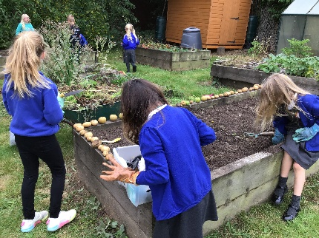
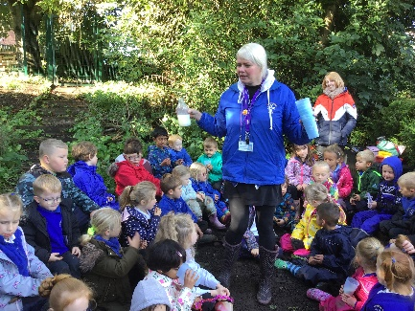

Road Safety
Mrs Brown is our Road Crossing Patrol Person, you will instantly recognise her with her bright clothing and large lollipop! Mrs Brown is there to help support family crossing the road down by the telephone box at the top of Mill Lane at the start and the end of the school day.
Main Street in Heather can be a very busy road especially at the beginning and end of the school day. We ask all parents and carers to park responsibly during these times, taking into account the safety of all pedestrians, road users and local homeowners.
Dogs
Dogs, even really tiny ones, are not allowed on the school grounds at any time.
No Smoking
Heather Primary is a Healthy School. It has a No Smoking and vaping policy that applies to all areas of the school property, both indoors and outdoors. This also includes PTA and social events that may take place on school grounds.
Money
We ask that children do not bring in money to school. Dinner money and money for trips etc can be paid via Weduc. Every family will get a Weduc log in once they have started.
Bringing things into school
We ask children not to bring into school anything of great value to them - financial or sentimental value... both apply! Sometimes children are keen to bring in something really special to show their friends and, if you're happy for them to do so, it's best to take anything of value straight to the class teacher so that we can look after your child's treasure during the day.
Often when a new craze occurs, the children often like to bring in their item, e.g. fidget spinner, Pokémon cards etc. Whilst this is not an issue, it is important that your child understands that these items are not to be played with in class or in the cloakroom during lesson time. Swapping of these items is not allowed in school. Often ‘swaps’ cause arguments and confusion, which take up a lot of the staff’s time to sort out and can also be distressing for the children involved. Unfortunately, at times, the school may make a decision to ban a particular item and your support in these matters is very much appreciated.

We also ask children not to bring into school:
- anything that could pose a risk to health and safety;
- fizzy drinks
- anything of any value
- mobile phones - If children bring mobile phones into school by mistake, we look after them in the school office until the end of the day.
- Nuts

Where there is any doubt about the suitability of something to be in school, we will look after any items during the day and return them to parents at home time. We also ask families to ensure that all items of clothing/water bottles/lunch boxes etc. are named/labelled so that they can be returned if they go astray during the school day.

