Learning Project Week 4: Healthy Me!
Class: Donaldson
Please complete at least 3 of the tasks below during the week:
We love to see what you are doing on our private Facebook Page or Twitter Feed: www.facebook.com/groups/heatherprimaryschoolcoalville
@HeatherPrimary
Weekly Maths Tasks | Weekly Reading Tasks
- Participate in daily Maths lesson from the Government Home Learning Website  - Continue working on Numbots  - Explore weighing and measuring food on the kitchen scales. Ask, what happens as you place more on the scales?  - Look for numerals on packaging you find around the house. Can your child recognise the numerals and count out a matching amount?  - Sing a range of number songs, such as ‘5 Currant Buns’, ‘5 Little Men in a Flying Saucer’ etc. | - Read a variety of books at home. Favourites can be repeated. Hearing the patterns of language in a story will support your child’s language development.  - Children to practise their tricky word flashcards regularly.  - Children to read to parents daily. Visit Oxford Owl for free eBooks that link to your child’s book band. You can create a free account. Complete the linked Play activities for each book.  - Look at recipe books and food magazines. Encourage your child to use their phonics knowledge to read the ingredients on the list. Select a recipe from there and make it together. You could lay the ingredients out and encourage your child to select the right one when you ask by reading the label, e.g. “Can you pass me the flour please?”  - Participate in daily phonics lessons 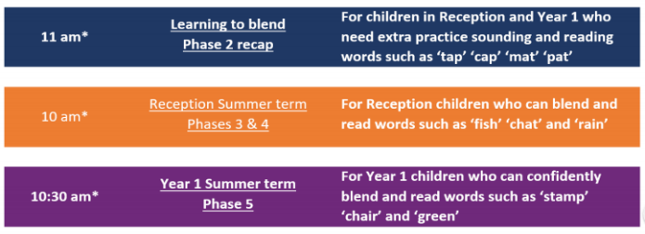
Weekly Phonics Tasks | Weekly Writing Tasks
- Sing Nursery Rhymes and songs together. Add in actions and change the words. Can children think of different rhyming words to add in? Repeat old favourites and learn new rhymes. You can find an A-Z of Nursery Rhymes here.  - Daily phonics - Practise the sounds in your child’s phonics book and blend to read words containing some of these sounds, e.g. b-oa-t. This can be oral blending (e.g. spoken out loud b-oa-t) or written if appropriate. Find some interactive games on www.phonicsplay.co.uk and Top Marks.  - Pour flour or rice into a shallow tray or plate. Show your child a letter, digraph, trigraph or tricky word and ask them to ‘write it’ in the food using their finger. | - Practise forming the letters of the alphabet.  - Ask your child to write out some of the tricky words they are working on at the moment (from their tricky word flashcards) on pieces of paper and turn them into a pairs game. You could work on a few each day, e.g. write out ‘I’, ‘go’ and ‘no’ twice, turn them over, and see if they can find the matching pairs.  - Ask your child to write out the ingredients for their dream meal. You could provide them with recipe books or look at recipes online. They could draw out the ingredients and label them and draw the finished meal. Some children may be able to write a few short sentences as instructions.

Learning Project – ongoing throughout the week: Healthy Me!
Choose from the selection below:

Sorting Healthy/ Unhealthy Foods:
- Look at a range of different foods found around the kitchen. Discuss with your child which ones they think are healthy and which are not so healthy. Can they sort them into healthy and not so healthy foods? Talk to your child about how it is fine to have treats every once in a while but not all of the time. We should have a healthy balance.

5 a day:
- Support your child to create a food diary to record how many pieces of fruit and vegetables they eat in a day. They could write these using their phonics knowledge or draw a picture of each item.

Potato/ Vegetable Printing:
- Using a selection of vegetables available in your kitchen, support your child to print and explore the shapes and patterns created.

Design a Healthy Lunchbox:
- Can your child design a healthy lunchbox?

Hunt for Food Growing:
- Do you have any food growing in your garden? Encourage your child and draw to label these, e.g. apple tree.

VE Day:
On Friday 8th May we will be celebrating VE day. Although celebrations will not take place in the way they usually would, you can still have your own VE day celebrations at home and talk to the children about how we are celebrating 75 years since World War Two ended. Most children will have heard of the amazing fundraising work that Captain Tom Moore has done recently, so you could talk to them about how he served our country during World War Two.

Here are some activity ideas for VE day:

- Create your own war bravery medal.

- Make your own VE day bunting or flags with union jacks or by colouring one red, one blue and having one white in a repeating pattern.

- Have a VE day garden party. You could make some cakes and help to make the sandwiches for it.

