Learning Project Week 4:
Class: Rowling 1
Please complete at least 3 of the tasks below during the week:
We love to see what you are doing on our private Facebook Page or Twitter Feed: www.facebook.com/groups/heatherprimaryschoolcoalville
@HeatherPrimary
Weekly Maths Tasks | Weekly Reading Tasks
- Participate in daily Maths lesson from the Government Home Learning Website  - Working on Numbots (year 1) and TT Rock stars (year 2)  Play on Hit the Button - number bonds, halves, doubles and times tables.  ● Play on Hit the Button - number bonds, halves, doubles and times tables.  ● Look in the cupboards and the fridge. Sort some of the foods you can find into different groups. Which food group has the most or least amount of items? Which item of food is the lightest or heaviest? Why might this be?  ● Play the game Fruit Fall - answer the data handling questions based on how many pieces of fruit you catch.  ● Choose and draw a 2D shape of your choice. List how many sides, vertices and lines of symmetry it has. | - Reading a variety of books at home. Your child could share a book everyday. This can be reading a book aloud everyday or sharing a book with an adult.  ● Read out aloud the ingredients on the back of a tin or cereal box to an adult?  ● Can you add the sound buttons onto three words?  ● Find a cooking book in the house or online and read the ingredients needed to make something.  ● Find a food leaflet in the house and read some of the items. Make a list of the food in alphabetical order and add on sound buttons.  ● Read a variety of books and make a list of all the different types of food you find.  - Participate in daily phonics lessons 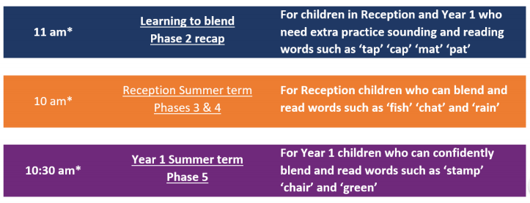  Please follow the schedule above, if your child is struggling with the Phase 5 phonics lessons then tune into the phase 2 or 3&4 – get in touch via WEDUC if you are not sure.
Weekly Spelling Tasks | Weekly Writing Tasks
● Daily phonics - your child to practice their sounds and blend words. Interactive games found on link below.  ● Phonics play  ● Top Marks  ● Spelling  ● Spell the days of the week: Keep a diary of things you do in the week.  ● Spell common exception words  ● Spelling Shed | - Create a shopping list for the week. Can your child group the items into food groups on their list e.g. fruit and vegetables, meat, dairy.  ● Write a recipe for a healthy meal of their choice. Can they use subheadings for the ingredients and instructions.  ● Design a new label for a cereal box. What eye catching information will you add? Can you use an exclamation mark?  ● Write a poem about your favourite food. Will it rhyme?  ● Design a new healthy smoothie. Which ingredients will you include? Can you label the smoothie? Will you have a mascot that is linked to your new creation? Can you make the smoothie?  ● Write a set of instructions on how to make your smoothie. Can they use imperative verbs e.g. (Put, cut, place etc)

Learning Project – ongoing throughout the week: Healthy Me!
Choose from the selection below.
The project this week aims to provide opportunities for your child to learn more food and exercise to keep us healthy. Learning may focus on different food groups, what makes a healthy meal, opportunities to cook, opportunities to exercise etc.

Balanced diet: Show your child this video about how to have a balanced diet.

Play these games about healthy eating. What do we have today? Look in the kitchen to see if you can create an A-Z list of foods.

Healthy eating plate: Use this sorting activity to sort items of food into their food groups- this will help with the next task.

Sorting activity: Collect food from the kitchen and sort into healthy and unhealthy foods.

Design a poster: Think about the foods you like to eat and food that you need to eat to keep you healthy. Create a poster that you can put in the kitchen or in the school hall. Will you be able to use any food wrappers or make your poster interactive?
Healthy lunchbox: can you play this game and make a healthy lunchbox?
Cooking: Find a few recipes and check if you have the ingredients at home and cook a meal for your family. Think about creating a balanced meal. Can you cook as a family? Who will do the measuring?
Exercise routine: Create an exercise routine, this could be a dance routine or something like Jo Wicks daily workout. You could set it to music and film it to share with your family or on the Facebook page so others can join with you.
Design a fact file: Design a fact file about why exercise is important in keeping us healthy. This could include why a warmup before a workout is important and why is important to cool down/stretch after exercise.
Fruit and vegetables printing: Look at the work of the artist: Lynn Flavell. How does she represent fruit and vegetables? Can you create a piece of artwork in the style of Lynn Flavell.

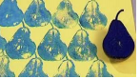
Look at the work of Giuseppe Arcimboldo. Using different drawing materials, can you create a picture of your own?
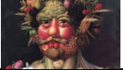

VE day: On Friday 8th May we will be celebrating VE day - celebrations will be a little different due to the current situation but we can celebrate with our family at home. Here are a few activities you might want to take part in. E

Research why VE day is an important day in history- What does VE stand for? Why are we celebrating it?

Create red, white and blue bunting to decorate the house- you could make this using different materials or simply make with paper.

Host a traditional English high tea using the ingredients or food items you have at home (when VE day happened the country was still on rations; you might like to research how they celebrated with limited food options). If the weather is good you could take this outside into your garden and have your very own garden party.

