[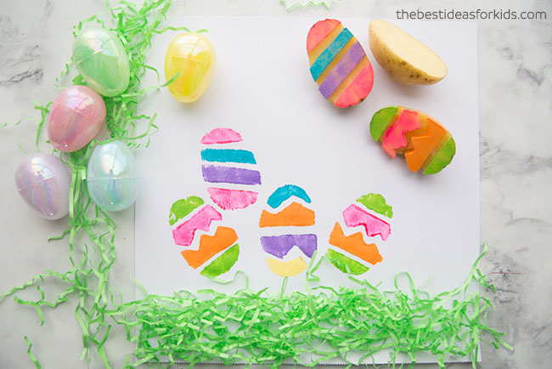](https://www.google.co.uk/url?sa=i&url=https%3A%2F%2Fwww.thebestideasforkids.com%2F20-easter-crafts-preschoolers%2F&psig=AOvVaw0Kmxd9mxkAhimSGLnBimhK&ust=1585838628757000&source=images&cd=vfe&ved=0CAIQjRxqFwoTCKD5wrm7x-gCFQAAAAAdAAAAABAP)

[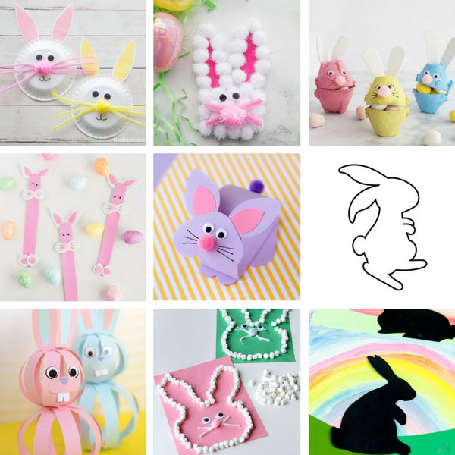](https://www.google.co.uk/url?sa=i&url=https%3A%2F%2Fwww.thebestideasforkids.com%2Feaster-crafts-for-kids%2F&psig=AOvVaw0Kmxd9mxkAhimSGLnBimhK&ust=1585838628757000&source=images&cd=vfe&ved=0CAIQjRxqFwoTCKD5wrm7x-gCFQAAAAAdAAAAABAK)

[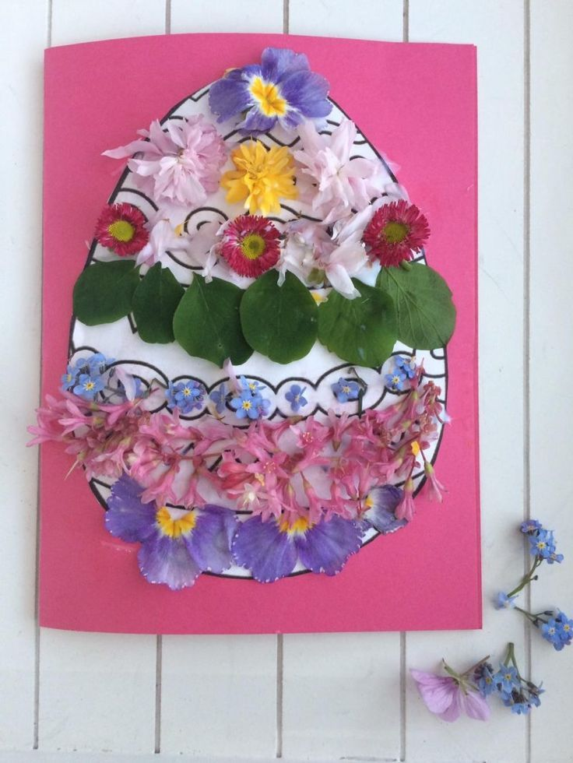](https://www.google.co.uk/url?sa=i&url=https%3A%2F%2Fwww.pinterest.com%2Fpin%2F200410252150097681%2F&psig=AOvVaw0Kmxd9mxkAhimSGLnBimhK&ust=1585838628757000&source=images&cd=vfe&ved=0CAIQjRxqFwoTCKD5wrm7x-gCFQAAAAAdAAAAABAb)

[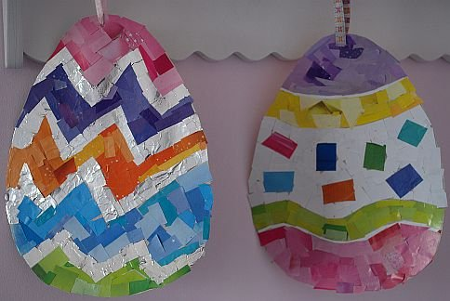](https://www.google.co.uk/url?sa=i&url=https%3A%2F%2Fwww.mykidstime.com%2Fthings-to-do%2F15-cutest-ever-easter-crafts-kids%2F&psig=AOvVaw0Kmxd9mxkAhimSGLnBimhK&ust=1585838628757000&source=images&cd=vfe&ved=0CAIQjRxqFwoTCKD5wrm7x-gCFQAAAAAdAAAAABAh)

[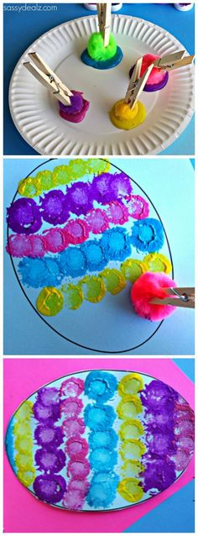](https://www.google.co.uk/url?sa=i&url=https%3A%2F%2Fwww.pinterest.com%2Fpediastaff%2Feaster-activities%2F&psig=AOvVaw0Kmxd9mxkAhimSGLnBimhK&ust=1585838628757000&source=images&cd=vfe&ved=0CAIQjRxqFwoTCKD5wrm7x-gCFQAAAAAdAAAAABAn)[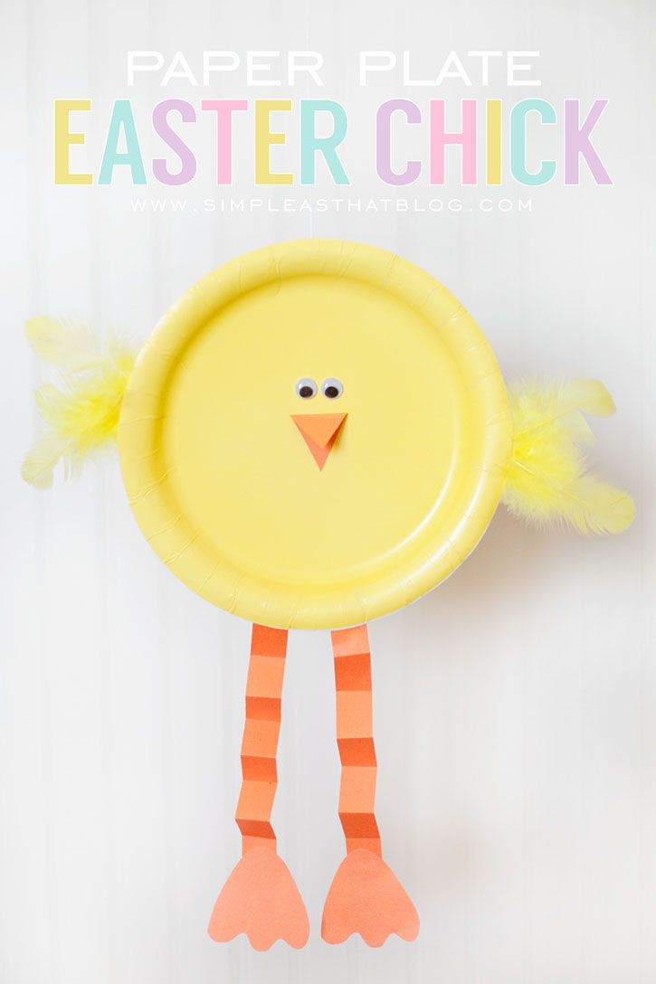](https://www.google.co.uk/url?sa=i&url=https%3A%2F%2Fwww.sheknows.com%2Fparenting%2Farticles%2F1078664%2Fsimple-easter-crafts-for-kids%2F&psig=AOvVaw0Kmxd9mxkAhimSGLnBimhK&ust=1585838628757000&source=images&cd=vfe&ved=0CAIQjRxqFwoTCKD5wrm7x-gCFQAAAAAdAAAAABAu)

[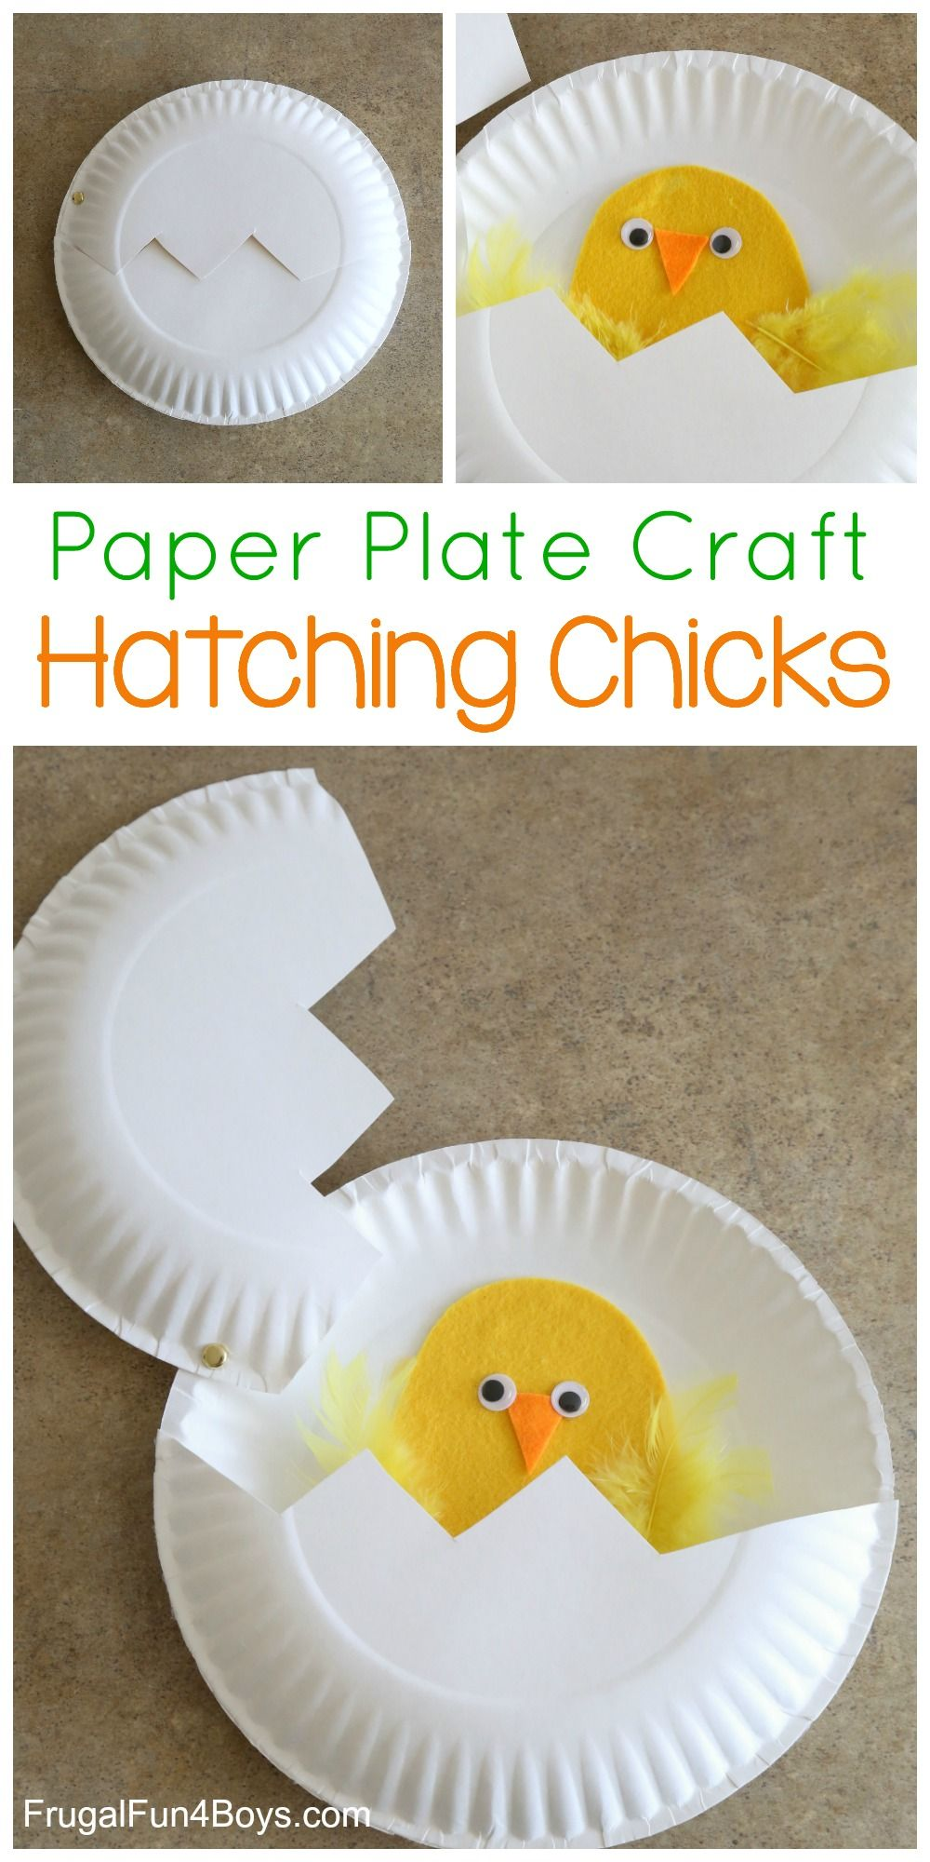](https://www.google.co.uk/url?sa=i&url=https%3A%2F%2Fwww.pinterest.com%2Fpin%2F95771929560528022%2F&psig=AOvVaw17veIRY15rbUwpuw-GdiSS&ust=1585839525782000&source=images&cd=vfe&ved=0CAIQjRxqFwoTCJCP3-G-x-gCFQAAAAAdAAAAABAO)

[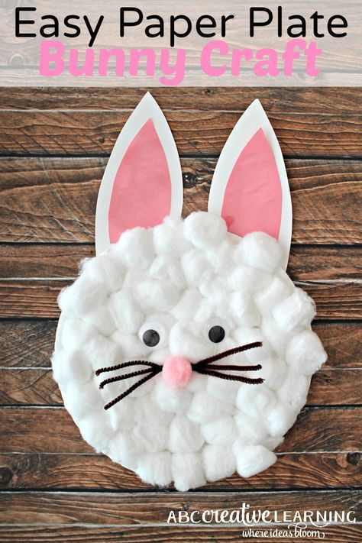](https://www.google.co.uk/url?sa=i&url=https%3A%2F%2Fwww.pinterest.com%2Fpin%2F12525705194706459%2F&psig=AOvVaw17veIRY15rbUwpuw-GdiSS&ust=1585839525782000&source=images&cd=vfe&ved=0CAIQjRxqFwoTCJCP3-G-x-gCFQAAAAAdAAAAABAT)