Learning Project Week 6: My Fantasy World!
Class: Donaldson
Please complete at least 3 of the tasks below during the week:
We love to see what you are doing on our private Facebook Page or Twitter Feed: www.facebook.com/groups/heatherprimaryschoolcoalville
@HeatherPrimary
Weekly Maths Tasks | Weekly Reading Tasks
- Participate in the daily maths lesson from the government’s home learning website: Government Home Learning Website. – week 11th May  - Continue working on Numbots  - Sing a range of number songs, such as ‘  Making simple patterns:  - Can your child make a repeating pattern using objects around the house/garden i.e. apple, banana, apple, banana. CHALLENGE: Ask your child to build on the above to create more complex patterns e.g. apple, apple, banana, apple, apple, banana.  - Ask your child to create repeating patterns with actions: Clap hands, tap knees, clap hands, tap knees. Make your own action patterns. CHALLENGE: one person makes the action pattern, the other person is to listen and repeat.  - Can your child join in with tongue twisters: red lorry, yellow lorry, red lorry, yellow lorry?  - Ask your child to make a simple shape pattern: https://www.topmarks.co.uk/ordering-and-sequencing/shape-patterns. | - Read a variety of books at home. Favourites can be repeated. Hearing the patterns of language in a story will support your child’s language development.  - Children to practise their tricky word flashcards regularly.  - Children to read to parents daily. Visit Oxford Owl for free eBooks that link to your child’s book band. You can create a free account. Complete the linked play activities for each book.  - Read the following story connected to this week’s topic: ‘The Night Pirates’ by Peter Harris and Deborah Allwright. Here is a link to the story: https://www.youtube.com/watch?v=KnVP6iBAvHg. Read the first four pages (up to 'Tom was a little boy about to have an adventure'). Before reading on, predict what the adventure might be.  - Participate in daily phonics lessons 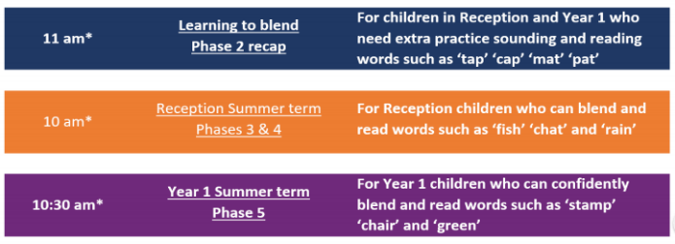
Weekly Phonics Tasks | Weekly Writing Tasks
- Sing Nursery Rhymes and songs. Repeat old favourites and learn new rhymes. You can find an A-Z of Nursery Rhymes here.  - Daily phonics - Practise the sounds in your child’s phonics book and blend to read words containing some of these sounds, e.g. b-oa-t. This can be oral blending (e.g. spoken out loud b-oa-t) or written if appropriate. Find some interactive games on www.phonicsplay.co.uk and Top Marks.  - Spelling Shed  - Create your own pirate ‘rubbish or treasure?’ phonics game like the one on ‘Phonics Play’. You could make a treasure chest template and rubbish bin template and write some real and nonsense words on coin shapes, e.g. ‘c-at’ for a real word and ‘c-a-v' for a nonsense word. Children read and sort the words by placing the real words in the treasure chest and the nonsense words in the bin. | - Practise forming the letters of the alphabet.  - Ask your child to write out some of the tricky words they are working on at the moment (from their tricky word flashcards) on pieces of paper and turn them into a pairs game. You could work on a few each day, e.g. write out ‘I’, ‘go’ and ‘no’ twice, turn them over, and see if they can find the matching pairs.  - Re-read the story ‘The Night pirates’. Make a map and tell the story.  Using a large sheet of paper, your child could draw a map and label to show the places in the story and Tom’s adventure with the girl pirates. Children could then use their map to help them tell the story. Maybe they could tell the story to a family member via video call.  - We have talked about and made ‘wanted’ posters in school a few times, e.g. for Goldilocks. Can you create a 'Wanted' Poster for the Night Pirates? Who might want to catch them? Why
Learning Project – ongoing throughout the week: My Fantasy World!
Choose from the selection below:
The project this week aims to provide opportunities for your child to explore the fantasy world of pirates.
What is day and night?
- Watch the video on BBC Bitesize: https://www.bbc.co.uk/bitesize/topics/zkvv4wx/articles/ztdnyrd
After watching, play the quiz. You could paint or draw a picture of how the sky looks at night and the sky in the day to show the difference between the two.

Make a flag:
- Design and make a new flag for the Night Pirates' ship.

Design a pirate ship:
- Design a new pirate ship for the Night Pirates. You could draw this on paper or outside using chalks. If you have a big cardboard box lying around, you might even like to make a pirate ship that you can fit in. You could decorate our ship, act out the story or have pirate adventures of your own!

Make a dream catcher:
- Make a dream catcher for Tom or the Night Pirates using twigs, wool, string, feathers or any other craft resources you have at home.
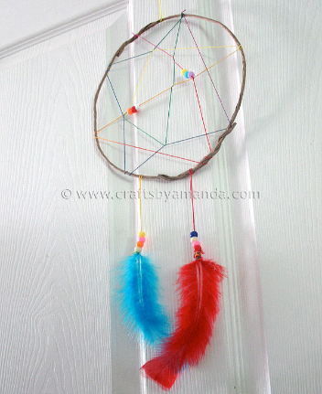

Make your own unicorn:
In a fantasy land you may see unicorns. Design and make your own unicorn using different materials around your home.
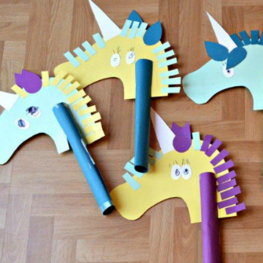

Music – Log on to Chrome Music lab:
https://musiclab.chromeexperiments.com/Song-Maker/
You can be really imaginative and create your own music. Use the Song maker tab to create some music or sounds for your fantasy world that your characters might hear.

PE:
Complete the daily task from the NWLSSP power point (sent on Weduc daily).

