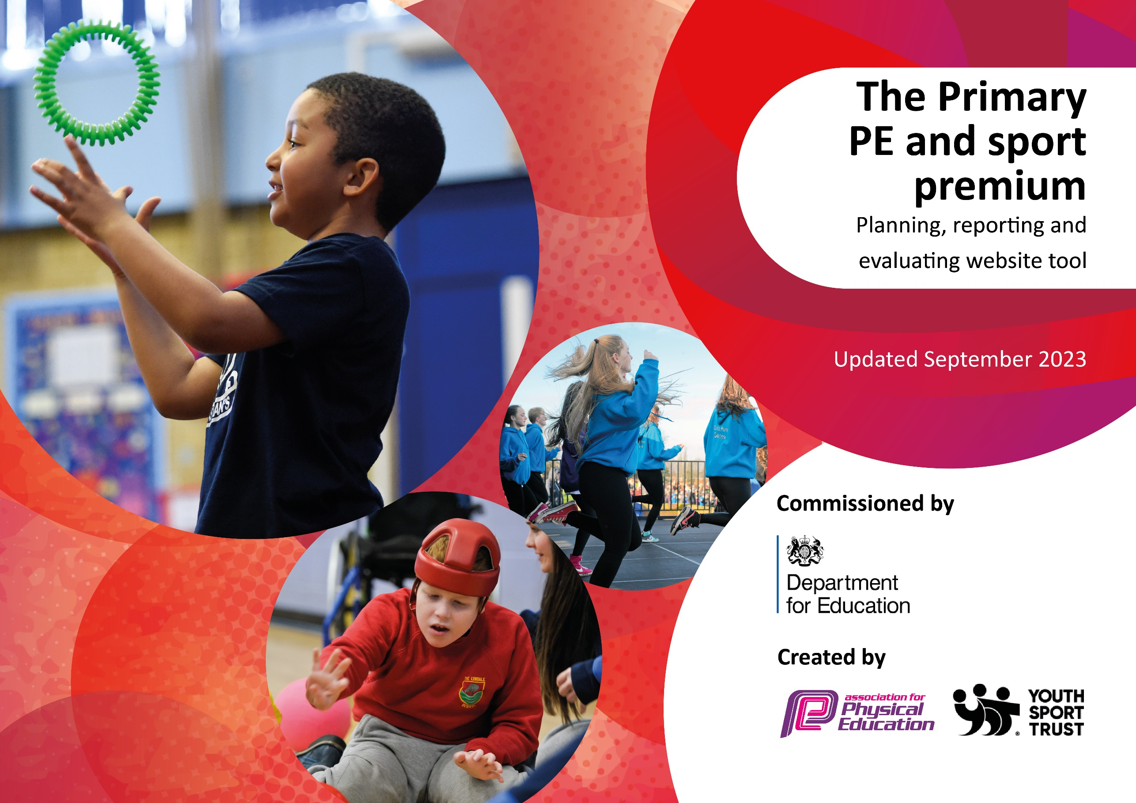

Heather Primary School 24-25

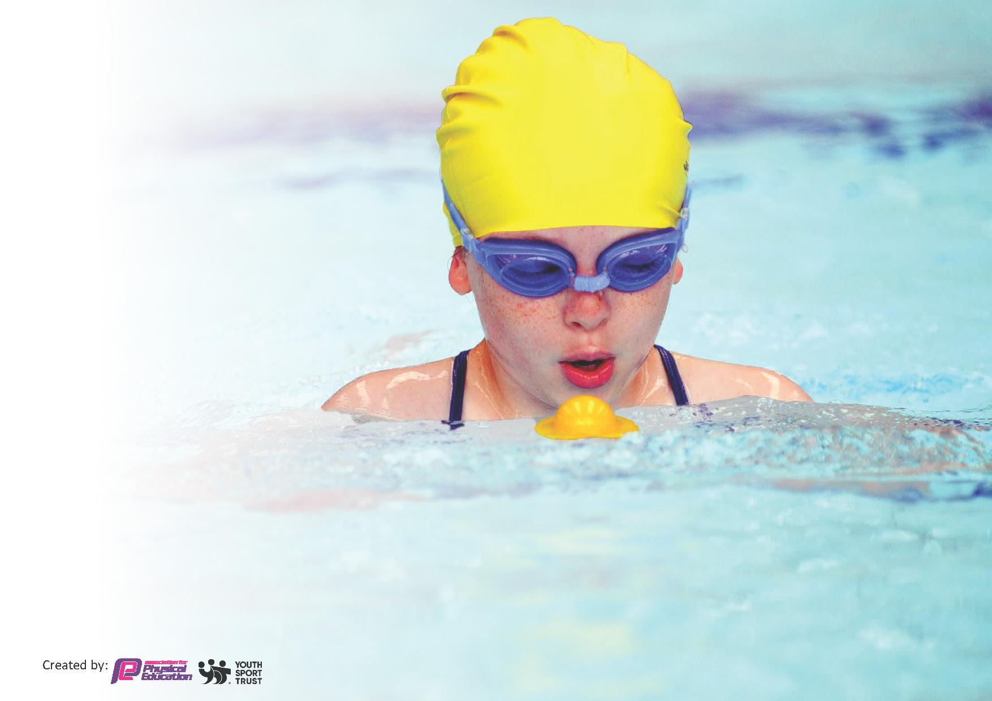
This template can be used for multiple purposes:
by:
- It enables schools to effectively plan their use of the Primary PE and sport premium
- It helps schools to meet the requirements (as set out in guidance) to publish information on their Primary PE and sport premium
- It will be an effective document to support Ofsted inspections enabling schools to evidence progress in Physical Education (PE) and evidence swimming attainment, which forms part of the PE National Curriculum. We would recommend schools consider
the Intent, Implementation and Impact of any spend, as examined within the Education Inspection Framework.

It is important that your grant is used effectively and based on school need.

Schools must use the funding to make additional and sustainable
improvements to the quality of the PE, School Sport and Physical Activity (PESSPA)
they offer. This means that you should use the Primary PE and sport premium to:

- Build capacity and capability within the school to ensure that improvements made now will benefit pupils joining the school in future years
- Develop or add to the PESSPA activities that your school already offers.

The Primary PE and sport premium should not be used to fund capital spend projects; the school’s core budget should fund these. Further detail on capital expenditure can be found in the updated Primary PE and sport premium guidance.

The Primary PE and sport premium guidance, outlines 5 key priorities that funding should be used towards. It is not

necessary that spending has to meet all the key priorities, you should select the priorities that you aim to use any funding towards.

Although completing this template is not a requirement for schools, schools are required to publish details of how they spend this funding. Schools must also outline what the impact this funding has had on pupils’ PE and sport participation and attainment and how any spending will be sustainable in the future. All funding must be spent by 31st July 2024.

The Department for Education has worked closely with the Association for Physical Education (afPE) and the Youth Sport Trust (YST) to develop this template and encourages schools to use it. This template is an effective way of meeting the reporting requirements of the Primary PE and sport premium.
Review of last year’s spend and key achievements (2023/2024)

We recommend you start by reflecting on the impact of current provision and reviewing your previous spend.

Key Achievements to Date | Comments
- School Games – Gold Mark 24-25  - All classes participate in 2 hours PE a week – enabling them to experience a variety of sporting opportunities  - Sports coaches provide CPD for teachers through a buddy system approach on a termly rolling programme  - All children participate in 2 PE lessons per week for 2 hours  - Extra-curricular sports clubs have been run in various sports with an inclusive ethos:  - Football – Year 2-6  - Netball – Year 3-6  - Running - Year 4-6  - Basketball – Year 3-6  - Summer Sports – Year 3-6  - Dodgeball – Year 3-6  - Dance – Year 3-6  - Tag Rugby – Year 1-6  - Olympic Super Stars – Year 1-6  - Nerf quest – year 1-6  - Indoor Athletics – Year 1-6  - Gymnastics – Year 1-6  - Alternative spots have been provided, including quidditch  - From Sept 24- July 25 we took part in the following NWLSSP competitions and events:  - Primary Ambassador Training  - Year 5/6 Play Coach training  - Year 5/6 Tag Rugby  - Year ½ Multiskill Festival  - Year 3 Multi Skill Festival  - Year 5/6 Sports Hall Athletics  - Year 5/6 development and excel dodgeball competitions  - Year 1/2 and 3/4 Dodgeball Festival  - Year 5/6 Basketball – excel and development competitions  - KS 2 New Age Curling  - KS 2 Archery  - Handball festival  - NWL get active Award ceremony  - Year 1-4 Inclusive Sport  - Year ¾ Hockey  - Swimming Gala  - Orienteering  - Dance festival  - 5/6 Hockey Tournament  - Personal Best Festivals  - Year ¾ tag Rugby Festival  - Year ¾ and 5/6 Quad Kids  - Saffron lane Athletics  - 5/6 Cricket Dynamos – Girls and Mixed  - 5/6 Netball  - HAP Day  - All children from 1-6 took part in at least 8 week swimming programme  - Key successes in Basketball, curling and cricket academic year  - Sporting success are shared with all stakeholders and social media  - Sports Day was enjoyed by all with the children completing a range of competitive races  Bikeability has taken place for year 5/6 children October 2024 – we were commended on how sensible and hardworking the children were. | - Continue to raise the profile of certain after school clubs to ensure a better up take  - Continue to offer a range of clubs to targeted groups to increase their participation in different sports.  - Continue to provide CPD through buddy teaching to allow teachers to put in place skills acquired through CPD in a supportive environment  - Ensure year 5/6 weak swimmers have extra sessions/time in the pool

Key priorities and Planning
This planning template will allow schools to accurately plan their spending.

Action – what are you planning to do | Who does this action impact? | Key indicator to meet | Impacts and how sustainability will be achieved? | Cost linked to the action
CPD for teachers and support staff | Teachers and support staff.  Pupils through improved PE delivery | Increase confidence, knowledge and skills of staff teaching in sport  Engagement of all pupils in regular physical activity  Increased participation in sport | Teachers and support staff more confident to deliver effective PE supporting pupils to undertake extra activities inside and outside of school, including teaching water safety and swimming and as a result improved % of pupil’s attainment in PE. | £4050 – for the coaches to support buddy coaching.  Also including costs of swimming coach for those children who are non-swimmers and the extra staffing costs to ensure there are enough adults in the pool to support these children.

Introduce a range of new lunch time equipment to all the children to be more active through imaginative and sustained physical play | Lunch time supervisors  Teaching staff and pupils | Engagement of all pupils in regular physical activity  Broader experience of a range of sports and activities offered to all pupils | More pupils are meeting their daily physical activity goal | £3000
Replace old PE equipment – goal posts, footballs, netballs, tennis rackets, range of different size balls to enable the children to use them in their PE sessions | Teaching staff and pupils | Engagement of all pupils in regular physical activity  Broader experience of a range of sports and activities offered to all pupils  More purposeful lesson due to sufficient quality equipment |  | £2518
Ensure all children selected are able to partake in competitions, festivals and sporting experiences | Teaching staff and pupils | Engagement of all pupils in regular physical activity  Broader experience of a range of sports and activities offered to all pupils  Increased participation in sport | Children are able to attend and take part in a weather of competitions and festivals allowing them to develop sporting resilience and determination to succeed. This is also aspirational as they are participating in new sports and may wish to try them outside of home | £2000
To improve the Forest School experience | Pupils | Broader experience of a range of sports and activities offered to all pupils | Development of the whole child and life skills | £500
To continue to engage with the wider sporting community through the membership of NWLSSP | Pupils | Engagement of all pupils in regular physical activity  Broader experience of a range of sports and activities offered to all pupils  Increased participation in sport | Broader curriculum delivered linked to up and coming competitions. | £3880
To improve swimming out comes for all children | Pupils | To ensure the weaker swimmers are taught by a suitably qualified swimming teacher | Children will be taught by qualified swimming teacher – high quality swimming teaching will enable children to make progress more quickly | £1050

Swimming Data
Meeting National Curriculum requirements for swimming and water safety.
Priority should always be given to ensuring that pupils can perform safe self-rescue even if they do not fully meet the first two requirements of the National Curriculum programme of study

Question | Stats: | Further context  Relative to local challenges
What percentage of your current Year 6 cohort can swim competently, confidently and proficiently over a distance of at least 25 metres? | 68% | Child new to the school never swam before  Several children have no exposure to swimming other than school swimming
What percentage of your current Year 6 cohort can use a range of strokes effectively [for example, front crawl, backstroke, and breaststroke]? | 68%

What percentage of your current Year 6 cohort are able to perform safe self-rescue in different water-based situations? | 87%
If your schools swimming data is below national expectation, you can choose to use the Primary PE and sport premium to provide additional top-up sessions for those pupils that did not meet National Curriculum  requirements after the completion of core lessons. Have you done this? | No | We arrange for our less confident children to either have a longer session in the pool or attend additional swimming with another year group.
Have you provided CPD to improve the knowledge and confidence of staff to be able to teach swimming and water safety? | No | ( school funds qualified swimming teachers)

Signed off by:

Head Teacher: | Maxine Michalowski
Subject Leader or the individual responsible for the Primary PE and sport premium: | Maxine Michalowski
Governor: | Becky Smith – PE Governor
Date: | 11th July 2025

