Learning Project Week 7:
Class: Rowling 1
Please complete at least 3 of the tasks below during the week:
We love to see what you are doing on our private Facebook Page or Twitter Feed: www.facebook.com/groups/heatherprimaryschoolcoalville
@HeatherPrimary
Weekly Maths Tasks | Weekly Reading Tasks
- Participate in daily Maths lesson from the Government Home Learning Website  Week commencing 20th May 2020  - Working on Numbots (year 1) and TT Rock stars (year 2)  - Get your child to have a go at the online game for subtraction facts up to 20.  - Give your child a number between 1 and 50 and ask them to list how many ways they could make the number using subtraction. Try 20 if this is too hard.  - Get your child to write a subtraction number bond to or within 10 - e.g. 9 - 4 = 5 or 7 - 2 = 5. Can they use these facts to find out the subtraction facts up to 100? E.g. 90 - 40 = 50 and 70 - 20 = 50.  - Encourage your child to practise different ways to subtract by playing these different activities.  ● Practise counting in 2s, 5s and 10s. This game could support this. | - Reading a variety of books at home. Your child could share a book everyday. This can be reading a book aloud everyday or sharing a book with an adult.  - Ask your child to select a book and imagine they are reading it in space. Try reading it with a torch just before bedtime.  - Children to read to parents daily. Visit Oxford Owl for free eBooks that link to your child’s book band.  - You can create a free account. Complete the linked Play activities for each book.  - Participate in daily phonics lessons 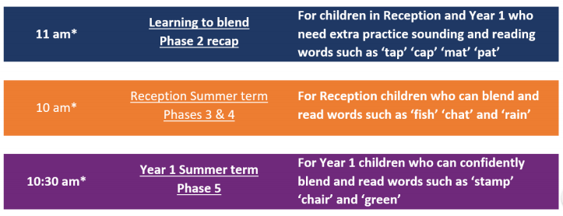  Please follow the schedule above, if your child is struggling with the Phase 5 phonics lessons then tune into the phase 2 or 3&4 – get in touch via WEDUC if you are not sure.
Weekly Spelling Tasks | Weekly Writing Tasks
● Daily phonics - your child to practice their sounds and blend words. Interactive games found on link below.  ● Phonics play  ● Top Marks  ● Spelling  ● Spell the days of the week: Keep a diary of things you do in the week.  ● Spell common exception words  ● Spelling Shed | - Ask your child to create a leaflet about a place in the UK they would like to visit/have visited. Include the weather, landmarks and cuisine..  - Your child could write a set of instructions for a meal they would love to share with family and friends. They can use illustrations too.  - Your child could write a letter to a friend or a family member who lives in a different part of the world or UK - describe where they live and describe school. Think of questions to ask about where they live and about their school.

Learning Project – ongoing throughout the week: The UK!
Choose from the selection below.
In this week's project your child will have the opportunity to discover the countries that make up the UK- they will achieve this by carrying out research, presenting information and art and design.

UK Discoveries
Find out about the countries that make up the UK- what are their famous landmarks, mountains, rivers and cities. Do any of the countries in the UK have their own language? You could create a poster including a map of the UK locating the features you have researched- Make sure you include some information about the areas you have pinpointed.
You may find this website helpful https://www.bbc.co.uk/teach/class-clips-video/psheeyfs-ks1-go-jetters-uk-places-and-landmarks/zkyjkmn

UK religions
In the UK we have lots of different religions-Watch the video where Charlie and Blue learn all about Hindu worship and then write or draw a picture about what you have learnt.
https://www.reonline.org.uk/resources/charlie-and-bluehear- all-about-hindu-worship/

Famous Brits

There are many famous names to have lived in the UK – Can you find out why they became so famous?
Here are a few names to help you get started:
- Charles Darwin
- Isaac Newton
- Ada Lovelace
- William Shakespeare
You could create a presentation of your findings and share it with your family members.

On your marks, get set, bake!

Try your own British Bake Off : https://www.bbc.co.uk/cbbc/shows/junior-bake-off
Create your own ‘Show stopper’ your family can be the judges. It would be great to see some of your creations shared on the Facebook page. Will you be ‘Star Baker’ this week?

Here are some British recipes to inspire you:
https://www.bbcgoodfood.com/recipes/herby-toad-hole - Toad in the hole https://www.bbcgoodfood.com/recipes/st-clements-pie - St Clements Pie https://www.bbc.co.uk/food/recipes/welshcakes_67264 - Welsh Cakes https://www.bbcgoodfood.com/recipes/orange-cranachan - Orange Cranachan (Scottish) https://discovernorthernireland.com/things-to-do/food-and-drink/traditional-northern-ireland-recipes/potatobread/ Potato Bread (Northern Ireland)

Get building

Choose one of the landmarks you discover and create it using junk.

