Learning Project Week 1:
Rowling 2
Healthy Me (PE, Science and PSHE focus)
VE Day
Please complete at least 3 of the tasks below during the week:
We love to see what you are doing on our private Facebook Page or Twitter Feed
www.facebook.com/groups/heatherprimaryschoolcolaville
@HeatherPrimary
Class:
Weekly Maths Tasks (1 per day) | Weekly Reading Tasks (1 per day)
My maths  Complete your My maths tasks daily, there are two tasks set each day and progress will be monitored by your teacher every day.  Complete the following lessons: Year 2 – Maths – WEEK 1 - Lessons 1-5 on the Oak National Academy website, as follows:  https://www.thenational.academy/  1.Identify Shapes by the number of sides and vertices  2.Identify right angles in shapes.  3.Recognise lines of symmetry in 2D shapes  4. Name and describe 3D shapes.  5. Identify 2 D shapes on surfaces of 3D shapes  These work well with my maths tasks that have been set recently. | https://www.thenational.academy/  Complete lesson 1 from Year 2 – English – WEEK 1 – The Firework Maker’s Daughter: To retrieve information  https://www.bbc.co.uk/bitesize/articles/zmp2mfr READING LESSON: Daisy and the Trouble with Life by Kes Gray. This clip and extract has 3 reading activities to do at home. Watch the clip and read the extract then try and do 1 activities per day.  https://www.oxfordowl.co.uk/for-home/find-a-book/library-page/ Sign up and log in (free) to access a wealth of free e-books from Oxford Owl’s Free e-book library. They can be filtered by book band so you can find ones that are suitable for your reading level 😊  https://www.educationquizzes.com/ks1/english/comprehension-aliens-stole-my-homework-summer-of-year-2/ An online comprehension quiz
Weekly Spelling Tasks (1 per day) | Weekly Writing Tasks (1 per day)
Weekly spellings:  er spelt with or after w  or spelt with ar after w  - Learn these words: word, work, worm, world, worth, worst; war, warm, towards, ward  - Choose one of your spelling words. Write an acrostic poem for that word.  *Example: Fun in the sky.  Laps around clouds,  Yes! I’m free!  - Oak National Academy will have ‘Common Exception Word’ spellings as part of their daily English lessons.  - Practice any previous spellings recorded in your school diary.  - Twinkl have lots of phonics/ Year 2 Common Exception Word printable activities.  - Make a Common Exception Word Bingo Game to play with your family | Writing tasks:  Postcard/Letter  Lots of children were evacuated to the countryside during the second world war. Imagine you were one of those children living in the countryside away from you parents. Write a postcard or letter to your parents telling them how you celebrated VE day with a street party and how much you are looking forward to returning home.  Party Invitation  Write a party invitation to your VE Day street party in the street where you live. Remember to include the following:  Who is invited  Date  Time  Place  Who it is from  If you can, follow the Year 2 English lessons schedule from WEEK 1 of the Oak National Academy – do 1 lesson per day. The focus text is: The Firework Maker’s Daughter – there is no requirement to have a copy of the text as it is all included in the online video 😊 All you need is a pencil and paper.
Learning Project – ongoing throughout the week.
Choose from the selection below.
VE DAY Activities
15cm
Design Technology: bunting
20cm
20cm
Create your own VE day bunting to display outside your house on Friday 8th May.
From paper make 10 triangles, measure them accurately. You can then decorate them with the union jack or anything you like but limit your colours to red, white and blue. Once you have made them sting them up by folding the widest part of the triangle over some string or wool and stick them down using glue, Sellotape or a stapler.

Design Technology: Plan a VE Day party tea. 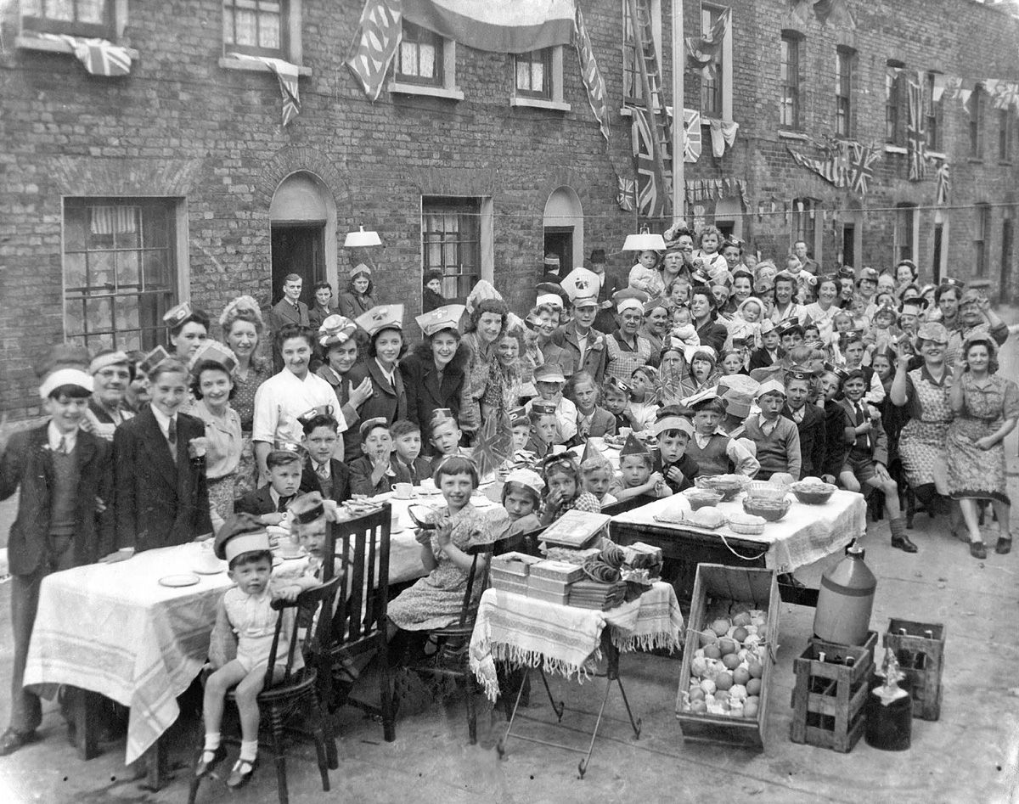
VE day was a day of great celebration and Many people had street parties. Food was still rationed at that time in May 1945 but people were creative and provided food for the party. Plan a VE Da tea party menu, you will first need to find out what kinds of food were available at the time then plan your party menu.
Science – Keeping our bodies healthy

It is especially important at this time to think about how we keep our bodies healthy. We must make sure that we eat a balanced diet, get enough exercise and the right amount of sleep. In our diet we must try to include foods from all of the food groups. These will help to maintain a healthy body. Look at the following clip https://www.bbc.co.uk/bitesize/topics/z9yycdm/articles/zxvkd2p
It includes fun information and games.
Then design a packed lunch that you could take on a pic-nic (which could be in your garden) that includes food from all of the groups.

PSHE -Think about the people who help us to stay healthy and well and about basic health and hygiene routines. Make a list of all the people in your life who do things to help you stay healthy. What do they do? What do they help you with? Don’t forget to include people outside your family like the dentist or the doctor

Music – Log on to Chrome Music lab
https://musiclab.chromeexperiments.com/Song-Maker/
It is really easy to create your own music. Use the Song maker tab to create a melody.

PE:
- Complete the daily task from the NWLSSP power point (sent on Weduc daily).
- Dance. Choose your favourite piece of music and have a workout to it, try to keep going for the whole song. Choose five different moves and list them down, repeat each move 8 times until you have completed the whole sequence then start again from the beginning.
- Ask an adult to help you take your heart rate before you start and after you have finished. What do you notice?

Useful Websites:
https://home.oxfordowl.co.uk/kids-activities/
https://www.educationquizzes.com/ks1/
https://www.topmarks.co.uk/
https://www.bbc.co.uk/bitesize/dailylessons

