Learning Project Week 3: Spring has sprung!
Class: Donaldson
Please complete at least 3 of the tasks below during the week:
We love to see what you are doing on our private Facebook Page or Twitter Feed: www.facebook.com/groups/heatherprimaryschoolcoalville
@HeatherPrimary
Weekly Maths Tasks | Weekly Reading Tasks
- Participate in daily Maths lesson from the Government Home Learning Website  - Continue working on Numbots  - Watch a Numberblocks clip each day at: BBC or CBeebies . Use this guide here to give you ideas on what to do with your children whilst watching an episode.  - Play a nature counting game. Can you find 5 of the same natural object or animal, e.g. 5 flowers? How about 6, 7, 8, 9 or 10? Some other examples could be: ants, leaves, stones, birds.  - Practise counting backwards from 20. This can be done through playing hide and seek, singing number songs, passing a teddy back and forth whilst counting, chanting, board games etc.  - Practise recognising amounts. This can be done by reading a dice when playing board games, playing with cards, identifying how many food items on the plate etc.  - Sing number songs to practise counting forwards and backwards: 5 Little Ducks, 10 fat sausages, 5 Little Fishes (this is a Kimbles action song that we sing regularly in the class so you could ask your child if they can teach you this one, including the actions | - Read a variety of books at home. Favourites can be repeated. Hearing the patterns of language in a story will support your child’s language development.  - Children to practise their tricky word flashcards regularly.  - Children to read to parents daily. Visit Oxford Owl for free eBooks that link to your child’s book band. You can create a free account. Complete the linked Play activities for each book.  - Participate in daily phonics lessons 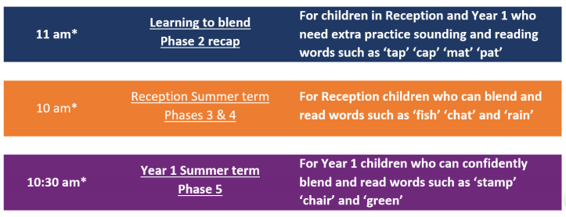  - Read the story ‘The Little Red Hen’ (or watch on Youtube if you do not have a copy of the book). You may find it as an eBook on the Oxford Owl website detailed above. After reading, ask your child: Why did the hen not want to share the bread with the other animals at the end of the story? Was this fair? Why? Why is it important to be helpful? Would you have helped the hen? Talk about what the hen had to do to make the grain of wheat/corn into flour. Could you make your own bread (if you are able to get hold of some flour)? Here is the recipe I usually follow when making bread in school with children: https://www.bbcgoodfood.com/recipes/easy-white-bread
Weekly Phonics Tasks | Weekly Writing Tasks
- Sing Nursery Rhymes and songs together. Add in actions and change the words. Can children think of different rhyming words to add in? Repeat old favourites and learn new rhymes. You can find an A-Z of Nursery Rhymes here.  - Daily phonics - Practise the sounds in your child’s phonics book and blend to read words containing some of these sounds, e.g. b-oa-t. This can be oral blending (e.g. spoken out loud b-oa-t) or written if appropriate. Find some interactive games on www.phonicsplay.co.uk and Top Marks.  - Sing the song, ‘Old McDonald Had a Farm’. Instead of saying the name of the animal, make the sound. Can your child guess which animal it is? They could write the digraphs/ trigraphs they can hear in the song e.g. ee, igh, ee, igh, oa | Linked to the story ‘The Little Red Hen’:  - Write the instructions for making bread.  - Write a sorry letter from the other animals to the hen, apologising for not helping to make bread.  - Lots of animals are born at Spring time. Draw a baby animal of your choice, e.g, a chick. Find out some information about the animal. You might like to create a fact file e.g. where does it live? What does it eat?
Learning Project – ongoing throughout the week: Spring has sprung!
Choose from the selection below:

The project this week aims to provide opportunities for your child to learn more about animals that are born in spring, as well as plants that bloom in spring. Learning may focus on exploring the physical aspects of an animal, their habitat, categorising animals, learning about how to take care of plants etc.

Finding out: How do plants grow?

The below video links in with our learning in class from last half term, teaching children about what plants need to grow:
https://www.bbc.co.uk/bitesize/topics/zpxnyrd/articles/zxxsyrd
On the website, below this video, it talks about where plants grow best. This could lead on to an experiment of planting the same type of seed in a few pots and placing them in different locations to observe which grows best over time.

Identify the birds in your garden

- Use the RSPB bird identifier website.
- Draw a picture of the birds you can see.

Play animal charades

- Take it in turns to act as different animals. Add in noises as a clue…

Learn the song, ‘The Animals Went in Two by Two’

- Ask your child to draw out two of each animal and practice writing the numeral 2.

Animals and their babies

- Draw as many animals as you can on one piece of paper and as many of their babies as you can on another sheet of paper. Cut them out and play a matching game to match the animals to their babies. Children might like to challenge you or their siblings to play the matching animals game.

Search for animal books in your house

- Ask your child to look through the books in your house and to find any with animals on the front cover. Ask them to sort the books into groups of their choice e.g. animals that can fly, swim, big, small, live on a farm/ at the zoo.

Create an animal den

- Provide your child with blankets and sheets to make an animal den. Act out being an animal in the den.

