Learning Project Week 6:
Class: Rowling 1
Please complete at least 3 of the tasks below during the week:
We love to see what you are doing on our private Facebook Page or Twitter Feed: www.facebook.com/groups/heatherprimaryschoolcoalville
@HeatherPrimary
Weekly Maths Tasks | Weekly Reading Tasks
- Participate in daily Maths lesson from the Government Home Learning Website  Week commencing 11th May 2020  - Working on Numbots (year 1) and TT Rock stars (year 2)  - Ask your child to find a book in your house. Can they find three items which are longer than the book and three items which are shorter? Order the items from longest to shortest. Measure the items to work out the difference in lengths.  - Can your child write down the name of each family in order from tallest to shortest. Is the tallest person the oldest person or not? Discuss why this might not be true. They could measure family members using a measuring tape.  - Play level 1 of this game to practise measuring things with a ruler. Write handy hints for using a ruler e.g. start at 0.  ● Practise counting in 2s, 5s and 10s. This game could support this. | - Reading a variety of books at home. Your child could share a book every day. This can be reading a book aloud every day or sharing a book with an adult.  - Ask your child to select a book and imagine they are reading it in space. Try reading it with a torch just before bedtime.  - Children to read to parents daily. Visit Oxford Owl for free eBooks that link to your child’s book band.  - You can create a free account. Complete the linked Play activities for each book.  - Participate in daily phonics lessons 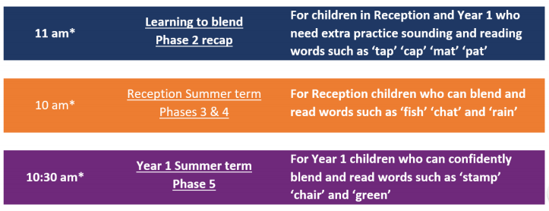  Please follow the schedule above, if your child is struggling with the Phase 5 phonics lessons then tune into the phase 2 or 3&4 – get in touch via WEDUC if you are not sure.
Weekly Spelling Tasks | Weekly Writing Tasks
● Daily phonics - your child to practice their sounds and blend words. Interactive games found on link below.  ● Phonics play  ● Top Marks  ● Spelling  ● Spell the days of the week: Keep a diary of things you do in the week.  ● Spell common exception words  ● Spelling Shed | - Ask your child to design their own Fantasy world and create a bank of adjectives to describe it and verbs to describe how animals, people or objects move.  - Now that they have designed their own fantasy land, ask your child to create an advertisement for the opening of their new land. What will they see? What activities will they be able to take part in? What time will the event start? How much does it cost to come to the event?  - Ask your child to plan their own trip to their fantasy land – what will they take and what will they do there? Record this in a timetable.

Learning Project – ongoing throughout the week: My Fantasy World!
Choose from the selection below.
The project this week aims to provide opportunities for your children to use their imagination to create a fantasy land. They will be exercising their literacy skill as well as their creative flare.

Creation stations:
create your fantasy world- could be a drawing/painting/model - This a good chance to recycle some of the cardboard the council aren’t collecting at the moment. To extend this further, children could label their creation.

Story mapping!
Now that you have created your fantasy world can you introduce some characters that live there. Plan out their story (see and example of how we would story map in school) - remember a good story needs an opening, build up, problem and resolution. Can you learn your story off by heart and include some actions to go with it. If you would like why not share a video of you telling your story to the school Facebook page. (Link at the top of the page)

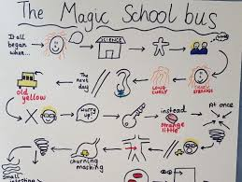

Don’t judge a book by its cover!
Create a front cover for your book remember that it must be eye catching. Give the reader a peek into your story but don’t give too much away. It must include the title of your story, a picture linked to you story and remember to add your name as the author. Why not take it further and create a blurb for your story – why not look at the blurbs of some your books to help you write this.

Become a composer:
Many great fantasy stories get turned into films and with that comes exciting music that helps to set the scene and allow viewers to feel different emotions.
Use this website to create your own piece of music for your fantasy world. Here is a clip from ‘The Lion The Witch and the Wardrobe’ when Lucy first enters Narnia. This might give you some inspiration.
https://www.youtube.com/watch?v=IC1_CidNWeo

