Learning Project Week 8:
Nurturing Nature
Please complete at least 3 of the tasks below during the week:
We love to see what you are doing on our private Facebook Page or Twitter Feed
www.facebook.com/groups/heatherprimaryschoolcolaville
@HeatherPrimary
Class: Rowling 2
Weekly Maths Tasks (1 per day) | Weekly Reading Tasks (1 per day)
My maths  Complete my maths tasks daily, there will now be one task set each day and progress will be monitored by your teacher every day.  There are two weeks lessons included.  Week 1  Complete the following lessons year 2 maths on Fractions 6-10 on the national oak academy website as follows:  https://www.thenational.academy/  - To identify unit fractions of a quantity  - To identify fraction of a quantity or shape  - To identify fraction of a quantity or shape  - To be able to identify equivalent fractions  - To consolidate and review  Week 2  Complete the following lessons year 2 maths on Capacity and Volume 1-5 on the national oak academy website as follows:  https://www.thenational.academy/  1.To be able to read the temperature on a thermometer  2.To estimate and measure in litres  3.To solve word problems that involve litres  4. To compare millilitres and litres  5.To use millilitres  Practice your times tables:  2, 5, 10 and make sure you know them off by heart then challenge yourself with  3, 4,6 times tables | https://www.oxfordowl.co.uk/for-home/reading-owl/library-page Choose a non-fiction book & write down 5 facts you found out from reading it.  Go on a reading scavenger hunt around the house – can you find words with this week’s spelling patterns in (e.g. -tion words / words with contractions).  https://www.wildlifetrusts.org/wildlife/how-identify/identify-garden-birds Research 5 garden birds – list their names alphabetically and write one fact about each of them. This will support your writing task of Keeping a bird-watching diary.  EXTREME READING! - Read a book in a bizarre place / position – the wackier the better! Get your grown up to take a photo and post it on the school’s private Facebook page if they can.  https://kids.classroomsecrets.co.uk/category/year-2/year-2-reading/ Sign up to Classroom Secrets Home Learning (free) and access their interactive Y2 reading activities. They also have printable activities and weekly learning packs for literacy and maths on their main Classroom Secrets Home-Learning page.
Weekly Spelling Tasks (1 per day) | Weekly Writing Tasks (1 per day)
There are two weeks spellings included as the project runs across two weeks  Weekly spellings:  Week 1  Words ending in -tion  Learn these words:  station, fiction, motion, national, section, addition, subtraction, potion, option, introduction.  Week 2  Contractions  - Learn these words:  can’t, didn’t, hasn’t, couldn’t, it’s, wouldn’t, shouldn’t, wasn’t  Once you have learnt your spellings, use them in some sentences. Try to use more than one word in each sentence. Make your sentences extended and start each sentence with a different word.  Practice reading and writing your year 2 common exception words.  Practice any previous spellings recorded in your school diary.  Spell the months of the year. | - Write a weather report. Choose a day in the week and find out what the weather is going to be, write a report that you can read out to your family. You can use your weather symbols from your art activity to use in your report.  - Keep a bird-watching diary of any birds that visit your garden – write down what sort of bird they are (https://www.wildlifetrusts.org/wildlife/how-identify/identify-garden-birds is a useful website) the time they visited, what they did.  - https://www.nationaltrust.org.uk/features/make-a-bird-feeder-from-recycled-materials Read the instructions on this website for how to make a bird feeder – they need to be improved! Re-Write them yourself usingtime connectives (First, Next, Then, After that, Finally etc) and adverbs (carefully, neatly, gently etc). Then have a go at making a feeder if you can 😊  - On Monday 8th June, it was “World Oceans Day”, research what this means and write an information text /persuasive poster about how to protect our oceans and sea creatures.  - Continue with Year 2 English lessons from https://www.thenational.academy/if you are still following them. WEEK 5
Learning Project – ongoing throughout the week.
Choose from the selection below.
Look after our beautiful World.

Recycling Activity.
Collect together 10 items from around the house. These could be food items, toys, clothes, shoes etc. List the items down and then decide if you could recycle those items when you have finished with them.
Eg.
Old coat –take to a charity shop

Design Technology
Using a recyclable container design a planter, see the ideas below. You can decorate it how you like. The ones below are all made from plastic bottles.
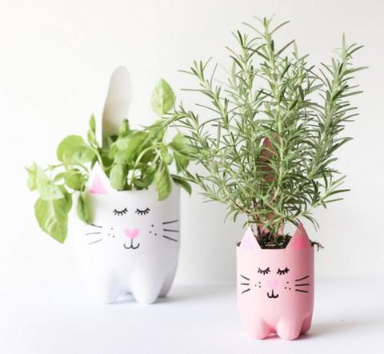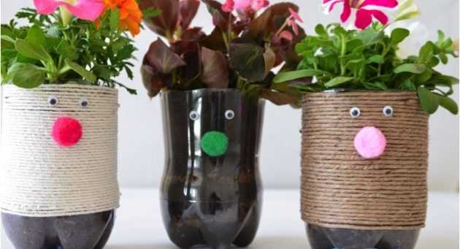
Science- Habitats
There are many endangered animals in the world. Choose an animal from the list below which is endangered and research its habitat. Where does it live? What climate does it need to survive? What does it eat? How does it breed? Why is it endangered?
Black Rhino
Hawksbill Turtle
Mountain Gorilla
Sumatran Elephant
Blue Whale
Red Panda
Present your information as a fact file with information and pictures/drawings. There are some great clips to watch on the BBC bitesize website. https://www.bbc.co.uk/search?q=endangered+animals
Geography- Water
Water covers about 71% of the earth’s surface. Look at a world map or globe and you can see how much of the earth is covered by water. Water is very precious, every living plant or animal needs water to survive. We must conserve water.
Think of ways we can save water and not waste it. Design a poster encourage people to be ‘Water Wise’. On it list/draw ways in which we can save and recycle water. I have included one idea to get you started.

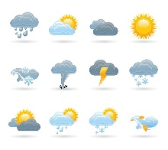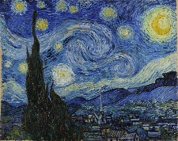
Art – Weather
Make some weather symbols to use in your weather support (see daily writing tasks). You can draw or paint them.

Create a picture in the style of a famous artist. Look online at the famous painting The starry night by Vincent Van Gough. Can you re-create this picture using paints? Look at the sky on a clear night, how bright are the stars? You may be able to see where Vincent Van Gough got his inspiration.

PE:
Complete the daily task from the NWLSSP power point (sent on Weduc daily).
Useful Websites:
https://www.bbc.co.uk/search?q=endangered+animals

