Learning Project Week 9:
Class: Rowling 1
Please complete at least 3 of the tasks below during the week:
We love to see what you are doing on our private Facebook Page or Twitter Feed: www.facebook.com/groups/heatherprimaryschoolcoalville
@HeatherPrimary
Weekly Maths Tasks | Weekly Reading Tasks
- Participate in daily Maths lesson from the Government Home Learning Website  Week commencing 22nd June 2020  - Working on Numbots - your child will have an individual login to access this.  - Write the days of the week on paper and cut them up into cards. Take turns turning over the cards. If, when you turn the card, you have a day that is before or after the day shown you can say snap.  - With your child, list different activities/chores they have to do throughout the day. Can they order them after making the list? Can your child sort them into the times of day each thing happens in (e.g. morning, afternoon, night etc)?  - Write the months of the year on separate pieces of paper and mix them up. Can your child order them correctly?  - Using a clock in your house practise telling the time with your child to the nearest hour, half hour, 15 minute intervals and 5 minutes intervals.  - Ask your child to survey the family about their favourite sea creature (choose from 5). Represent the results using a tally chart or a pictogram. Which sea creature was the most popular? Which was the least popular? | - Reading a variety of books at home. Your child could share a book everyday. This can be reading a book aloud everyday or sharing a book with an adult.  - Encourage your child to learn the rhyme ‘A Sailor went to Sea, Sea, Sea’. Click here for a video of the rhyme and lyrics. Can your child perform this rhyme by heart?  - Task your child with building an ‘Under the Sea’ themed reading den. Can they find some sea-themed books to cosy up with and share in there?  - Ask your child to make a sea-themed bookmark. They could take inspiration from ‘Sharing a Shell’ or ‘The Snail and the Whale’.  - Your child could read a story/poem/nursery rhyme to another family member. This could be to a younger sibling before bedtime or they may wish to Facetime an elderly relative (with adult supervision of course).  - - Read along with ‘There’s a Hole in the Bottom of the Sea’ or listen to ‘How the Whale got his Throat’. Ask your child to retell one story by drawing a comic strip of the events.
Weekly Spelling Tasks | Weekly Writing Tasks
● Daily phonics - your child to practice their sounds and blend words. Interactive games found on link below.  Phonics play  Top Marks  Spelling  Spell the days of the week  Spell common exception words  Spelling City  - Participate in daily phonics lessons 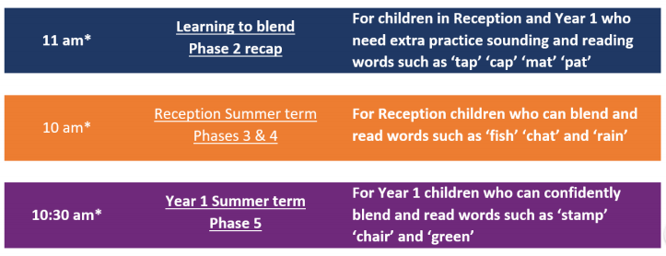 | - Visit a desert island here. Ask your child to write a message in a bottle. What can they see, hear, feel, taste and smell? Why not roll the message up and pop it in a plastic bottle for the reading den?  - Task your child with planning the perfect beach trip. Ask them to draw and label all of the things that they would pack including a picnic. Who would they take? What games would they play? How much time would they spend in the sea?  - Speak to your child about all of the things that make them happy or all of the things that they’re grateful for. Ask them to record these in a list.  - Help your child to create a fact file about the endangered Sea Turtle. Can they find out about its appearance, its diet and its habitat? This link may help. Following this, your child could draw a detailed sketch of the Sea Turtle.  - Visit the Literacy Shed for this wonderful resource on The Lighthouse. Or, Your child could design a beach safety poster. What tips would they give beachgoers for staying safe at the seaside?

Learning Project – ongoing throughout the week: Under the Sea
Choose from the selection below.
The project this week aims to provide opportunities for your child to learn more about life in and around the sea. Learning may focus on the strange and wonderful creatures and plants that occupy our oceans, their habitats and how human beings affect this environment.

Guess Who?
Ask your child to write fact cards about animals from under the sea. They can use books or websites to find out about the appearance, habitat and diet of each creature. After this, play a game of ‘Guess Who?’ using the cards and yes/no questions.

Junk Modelling-
Using junk or recycling materials from around the home, ask your child to design and make a Sea Turtle. Your child may wish to make another sea creature after this. Share your creations on the Heather Facebook page.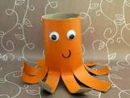
Create paper port holes from a submarine where the children can draw or paint what they could imagine seeing under the sea.
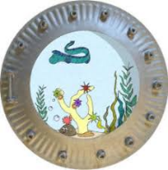

Put Your Goggles On-
Your child can visit this website and watch a live stream of a tropical reef. Whilst watching, ask them to sketch all of the animals that they can see. Remind them to look at the shapes and patterns on each creature and to include these in their sketches.

How do Humans Affect the Sea? -
Is your child aware of all of the ways that humans affect the sea and the living things within it? Talk about and investigate the impact that human beings have on the sea. Think about fishing, transport and pollution. Create a poster or information report.

The Oceans of the World-
Using an atlas or the web ask your child to identify the world’s oceans. Year 1 children may need some support with this. Can they find out what animals live in each ocean? This game allows your child to practise naming and locating the oceans.

Music-
Learn the song ‘Under The Sea’ from The Little Mermaid - create your own actions and show them off on the Facebook page.

STEM learning activity- #sciencefromhome
Unplugged Coding
- Watch this video.
- Create a simple under the sea obstacle course or draw an obstacle course on a piece of paper. Write simple code to guide the submarine around the obstacles found under the sea. E.g. Rocks, shipwrecks, sleeping octopus. E.g. →→↓→→↑→ etc.
- Look at the life cycle of a turtle- Present this in a poster using pictures, labels and captions.

PE activities
Watch videos of sea creatures and how they move. Ask your child to copy the creature's movements and move around a space in this style. Look at crustaceans, like fish, bottom feeders and octopi.

Think about how to move your body like an octopus –knees-hips-head and shoulders-elbows-hands. This is a great on the spot exercise for body coordination and for the children to focus on and follow instructions.

