Learning Project Week 2:
Class: Rowling 1
Please complete at least 3 of the tasks below during the week:
We love to see what you are doing on our private Facebook Page or Twitter Feed: www.facebook.com/groups/heatherprimaryschoolcoalville
@HeatherPrimary
Weekly Maths Tasks | Weekly Reading Tasks
- Participate in daily Maths lesson from the Government Home Learning Website  - Working on Numbots (year 1) and TT Rock stars (year 2)  - Play on Number Fact Families - find the addition and subtraction fact families for numbers up to 20, 50 or 100.  - Practise counting in 2s, 5s and 10s. This game could support this.  - Go out in the garden and observe the different creatures/animals that can be seen. Count how many of each animal/creature you can find.  - Practise learning about money by playing this game. You could also use real coins and play a similar game with family members.  - Select a number between 2 and 20. Make a poster showing how many different ways to make this number using addition, subtraction, multiplication etc. | - Reading a variety of books at home. Your child could share a book everyday. This can be reading a book aloud everyday or sharing a book with an adult.  - Can you read fiction, non- fiction and poems about animals?  - Can you find adjectives in the books used to describe spring?  - Listen to the stories: https://www.storylineonline.net/books/clark-the-shark/  - https://www.storylineonline.net/books/library-lion/  - Create a bookmark with facts about spring or animals that are born in spring.  - Participate in daily phonics lessons 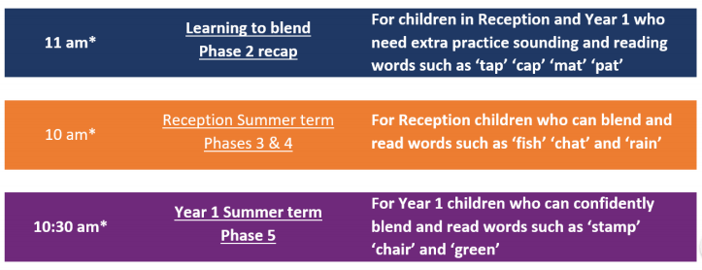  Please follow the schedule above, if your child is struggling with the Phase 5 phonics lessons then tune into the phase 2 or 3&4 – get in touch via WEDUC if you are not sure.
Weekly Spelling Tasks | Weekly Writing Tasks
● Daily phonics - your child to practice their sounds and blend words. Interactive games found on link below.  ● Phonics play  ● Top Marks  ● Spelling  ● Spell the days of the week: Keep a diary of things you do in the week.  ● Spell common exception words  ● Spelling Shed | - A-Z Animal or plant list: Can you think of an animal for each letter of the alphabet. Can you add sound buttons?  - Draw a picture of your spring animal or plant and label it. Can you write sentences using adjectives?  - Write a set of questions about spring animals or plants you would like to find out about.  - Create a fact file about your favourite spring animal. Research an animal of your choice and explore the vocabulary required to describe them.  - Describe similarities and differences between animals.

Learning Project – ongoing throughout the week : Spring Has Sprung!
Choose from the selection below.
The project this week aims to provide opportunities for your child to learn more about key animals that are born and plants that bloom in spring they are interested in. Learning may focus on exploring the physical aspects of an animal/ Structure of a plant, their habitat/where they grow, categorising animals/ what family does the plant belong to.

Find out about:
How does spring affects plant and animals?
What happens to plants?
How to the weather help both plants and animals in the season of spring?
https://www.bbc.co.uk/teach/class-clips-video/science-ks1-ks2-seasonal-changes-behaviour-animals-growth-cycle-plants/zfynvk7

Create a mask :
Using different materials around the house, create a mask of their favourite springtime animal. Think about the colours and shape. Can they add different textures to their mask?

Spring check list:
Take this learning outside into the garden or maybe this could be done whilst out on your daily exercise. Using this spring check list to see if spring has sprung in your garden or in your local area. You could extend this task may asking the children to make a list of the types of plants, insects and animals they see whilst they are on their spring hunt.

Flower dissection:
Can they find a daffodil (tulips also work well) to dissect and find out about the parts of the plant and how they help the plant to grow and reproduce? To help the children with this they can follow this live dissection on YouTube where they will also find out about how important certain parts of the flower are. (Make sure to take some pictures to share with us all) Once the children have completed the dissection can they draw a picture of the flower showing its structure. See example bellow:
