Class: Rowling 2
Learning Project Week 3:
Spring has sprung! (Science and Nature focus)
Please complete at least 3 of the tasks below during the week:
We love to see what you are doing on our private Facebook Page or Twitter Feed
www.facebook.com/groups/heatherprimaryschoolcolaville
@HeatherPrimary
Class: Year 2 Rowling
Weekly Maths Tasks (1 per day) | Weekly Reading Tasks (1 per day)
My maths  - Complete your my maths tasks daily, there are two tasks set each day and progress will be monitored by your teacher every day.  - Practice your 2, 5 10 and 4 x tables from previous weeks.  - Practice your skills on ‘Snappy Maths’ and ‘TTRockstars’  - Maths Focus – Length/Height. Use a ruler or tape measure. In your garden measure different objects accurately to the nearest cm. You could choose a particular plant and chart its growth over the next week.  - Use a tape measure to measure the height of all of the members of your family. List them down in order shortest to tallest.  - List down the months of the year in order, remember to check your spellings. Answer the following questions.  - Which is the second month of the year?  - Which month is between August and October?  - Which month is likely to be hot?  - Which month might be very cold?  - Which is the third month of the year? 6. When do leaves fall from the trees?  - When do we celebrate Christmas?  - Play this game with a member of your family. Think of your own clues and ask your family member to guess the month. Take turns.  - Eg. I am thinking of a month. It is the month that lambs are born in. What is the month? | Log onto https://www.roythezebra.com/ and try some of the different reading & spelling activities. There should be enough to do one per day.  Read some non-fiction books.  Find some interesting facts from them and write your own quiz for a friend or relative. You could use Zoom or another video calling platform to try out your quiz.  Try out a Year 2 Comprehension from Twinkl. Either print it out to write your answers down or read it on-screen and answer out loud to a grown up if you don’t have access to a printer.  Keep reading for pleasure – try and include a variety of genres:  *Poems  *Non-Fiction  *Newspaper Reports  *Stories  *Instructions/Recipes
Weekly Spelling Tasks (1 per day) | Weekly Writing Tasks (1 per day)
Weekly spellings:  Think about words with the ‘o’ sound spelt with ‘a’ after ‘w’ and ‘qu’  - Learn these words: want, watch, wander, quantity, squash, quality, squabble squad, quad, quarrel  - Look the spellings up in a dictionary and write the meaning of each word.  - Practice reading and writing your year 2 common exception words.  Practice any previous spellings recorded in your school diary. | *Write a set of instructions – these could be real (How to make …) or creative (e.g. How to wash a Hippo). Remember to include:  *Title  *Equipment/Ingredients list  *Numbered Steps  *Time Connectives (First, Next, Then, After that, Later on, Finally...)  *Adverbs (ly) carefully, gently, slowly...  *Safety Tip  *Diagrams/Pictures to help  *Keep a daily ‘Lockdown’ Diary of things you have been doing.  *Write a SPRING acrostic poem  *Write an explanation about the lifecycle of a butterfly or a frog.  *Write a weather report and have a go at presenting the weather to a grown up (Like we did in one of our Science lessons)
Learning Project – ongoing throughout the week.
Choose from the selection below.
Science – (link to maths)

Make a four seasons wheel, you could draw around a dining plate. In each section you can add details or pictures of what usually happens during that month. Include festival’s like Easter, Christmas and special days like St Georges Day and Bonfire Night.

Investigate rainbows!
Rainbows are a particularly important symbol at the moment.
Have you ever seen a rainbow in the sky? Do some research about rainbows.
When do they appear? Why do they appear?
Make a rainbow – Science experiment.
You will need:
A glass/bowl of water or water spray from a hose
Sunny window or sunny outside area
A piece of white paper
  - Carefully place your glass or bowl of water on a sunny window sill
  - Look around the glass, on the walls or on the floor to see a rainbow. It might be easier to see the rainbow by moving a piece of white paper by the glass.
This experiment can also be done outside on a sunny day. Use a hose to create fine mist of water and hold it up in the air – you should be able to see the rainbow through the mist! Remember to have your back towards the sun to do this experiment.
Music – Birdsong. The roads are very quiet at the moment with not much traffic passing by and it makes it easier to hear the birds in our countryside. Go out into your garden in the morning and listen to the songs of the birds. Then go on to you tube and listen to the bird song of these English countryside birds https://www.youtube.com/watch?v=RHnzqKfxSQw
After listening to the clip you may be able to identify the birds in your garden by the sounds they make. You could keep a log of which birds you see or hear each day. There is more information about birdwatching at:
BBC Spring watch – How to bird watch from home.

Art- Sculpture. Collect some things from your garden or when out on your daily walk eg: sticks of different sizes, stones, fallen leaves, feathers. Use the things you have found to create a sculpture. Remember to wash your hands afterwards!
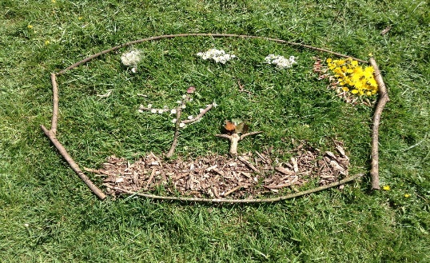
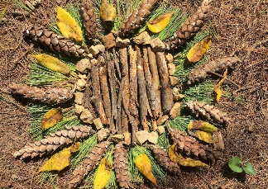
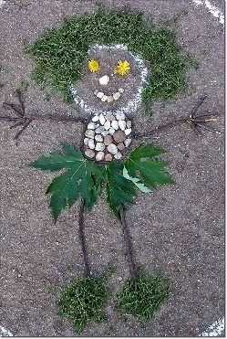

Geography – Draw a map of your daily walk or download a map of your locality and plan some walks that you could go on with your family. You could plan a different route every day shown in a different coloured pen.

Useful Websites:
BBC Bitesize (type birdwatching into the search bar for some interesting video clips).

https://www.thenational.academy/ - See Supporting Letter. You will be directed to suitable activities each week by your class teacher.

Topmarks – online educational games
MathsFrame – free maths games
Twinkl – A wealth of worksheets for all subjects (if you have access to a printer)

