Learning Project Week 1: Learning Project Week 6:
My Fantasy World
(Literature and the Creative Arts focus)
Please complete at least 3 of the tasks below during the week:
We love to see what you are doing on our private Facebook Page or Twitter Feed
www.facebook.com/groups/heatherprimaryschoolcolaville
@HeatherPrimary
Class: Rowling 2
Weekly Maths Tasks (1 per day) | Weekly Reading Tasks (1 per day)
My maths  Complete my maths tasks daily, there will now be one task set each day and progress will be monitored by your teacher every day.  Complete the following lessons year 2 maths 11-15 on the national oak academy website as follows:  https://www.thenational.academy/  To make predictions about shape  To be able to rotate shapes  To be able to identify how patterns have been created through rotation.  To follow a route around a map  To consolidate and review  - Find shapes/logos around the home, are they symmetrical, can you draw them and show the line of symmetry as a dotted line, look at the examples below.  - Draw some symmetrical insects for your fantasy world, cut them out and add them to your back ground. | Read the story ‘Alice In Wonderland’ on you tube (audio books) if you don’t have your own copy of it.  Draw one of the characters from Alice in Wonderland and write a character description about them using what you’ve inferred about them from the story.  https://www.twinkl.co.uk/resource/lks2-alice-in-wonderland-differentiated-reading-comprehension-activity-t2-e-41966 Although it is aimed a lower KS2 (Y3), Twinkl have a wealth of Alice in Wonderland PPTs, comprehensions, character profile activities etc. If you’re able to access them on the free coronavirus log-in, there are many printable activities available.  Research any other stories with fantasy settings. Compare them to a story with a familiar setting. What’s similar? What’s different about them in terms of: setting, characters, plot etc?  Keep logging onto First News https://live.firstnews.co.uk/ for daily top stories.  https://www.bbc.co.uk/bitesize/articles/zd63gwx Cyril & Pat by Emily Gravett with 3 activities to try.
Weekly Spelling Tasks (1 per day) | Weekly Writing Tasks (1 per day)
Weekly spellings:  The suffixes -ment, -ness, -ful. Plan your own story using a story map like the ones we have used before.  - Learn these words:  - enjoyment, sadness, careful, playful, plainness, argument, merriment, happiness, plentiful, cheerful.  - Once you have learnt your spellings write them in alphabetical order. Use a dictionary to find the meanings of each word. Write the meanings down.  - Practice reading and writing your year 2 common exception words.  - Practice any previous spellings recorded in your school diary. | Plan your own story using a story map like the ones we have used before. Think about the:  Setting  Characters and a main character  The adventure and problem  The resolution  The happy ending.  Draw your story map see the example below  Then write your story following your map.  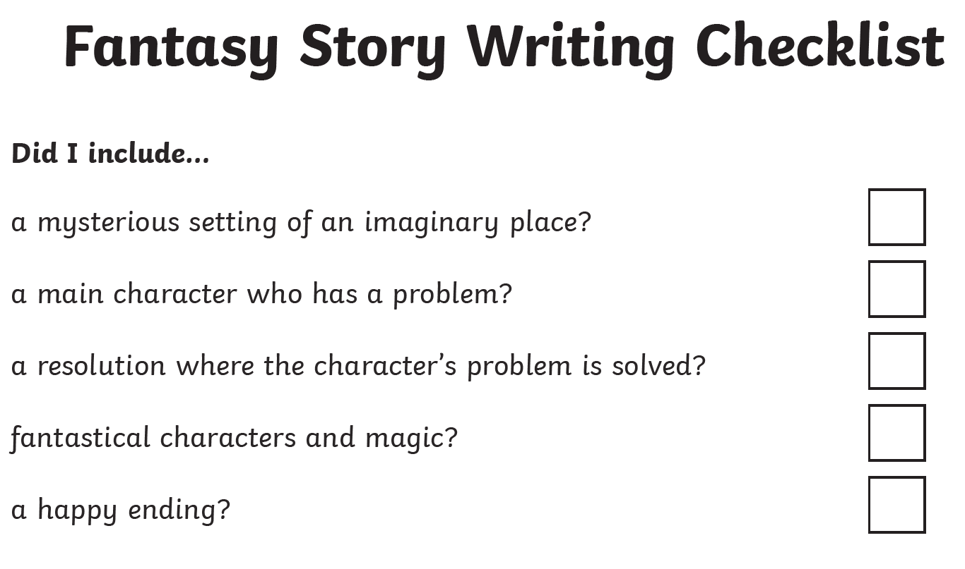  Use the checklist to make sure you have included all the details.  Also available are the continued ENGLISH lessons from National Oak Academy, based around ‘The Firework Maker’s Daughter’. Work through the WEEK 3 lessons.
Learning Project – ongoing throughout the week.
Choose from the selection below.
Art – Paint a picture. Think about the story of ‘Alice in Wonderland’. She was transported to a strange fantasy world where she met strange characters. On a large piece pf paper draw or paint your own fantasy world. It can be as strange as you like. When you have completed it you can stick it to card or a cardboard box so that it stands up, this can be your back drop.

Technology- Draw some characters on paper and glue them to card, use card to make them stand up as in the picture. Use an old shoe box and some craft materials (if you have them) to turn your fantasy world picture into a 3D fantasy landscape. Try hanging things in it or standing your characters in it.
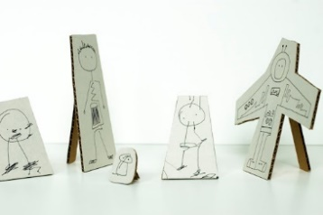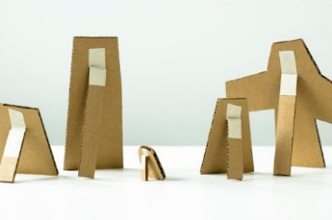
Design a menu for a Mad Hatter’s Tea Party then have a go at making some of the snacks. Write up the recipes and do some taste testing with your family. Have a tea party picnic in your garden.

Music – Log on to Chrome Music lab
https://musiclab.chromeexperiments.com/Song-Maker/
It is really easy to create your own music. Use the Song maker tab to create some music or sounds for your fantasy world that your characters might hear.

PE - Complete the daily task from the NWLSSP power point (sent on Weduc daily).

Useful Websites:
https://musiclab.chromeexperiments.com/Song-Maker/

