School Uniform
We ask children to wear school uniform, which ensures that the whole school looks smart and helps to give everyone a sense of pride in representing our school. Our uniform is:
- Grey/black trousers/skirt or pinafore dress
- Royal blue/white polo shirts – ones with the school logo on are available from our uniform suppliers
- Royal blue sweatshirt, cardigan or fleece – again available from our uniform suppliers
- In the summer grey/black school shorts (not denim or sports wear) or blue gingham dress/skorts may be worn
- Plain, white/black/grey socks or tights
- Black sensible shoes – no open toes, no heel more than 3 cm

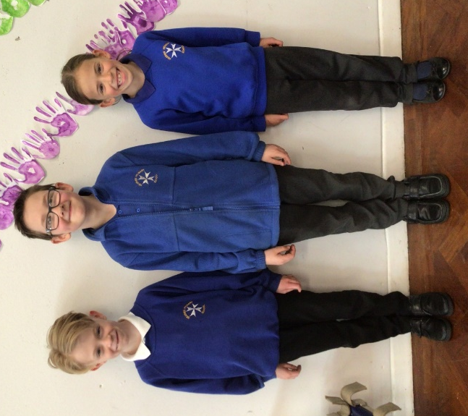
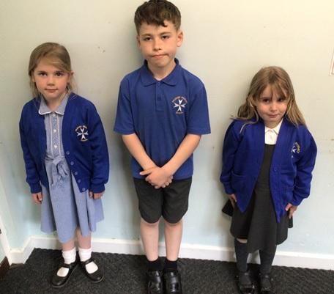

School uniform can be ordered from www.ept-schoolwear.co.uk who are based in Coalville or www.pmgschoolwear.co.uk. Items can be ordered to be delivered direct to you or collected if ordering through EPT. Please allow at least 28 days for delivery at busy times.
We do have some pre-loved uniform in school. Please ask at the school office if you would like to see what we have.
Please make sure all uniform is named – it helps us reunite lost items quickly as it can be distressing to children if they can’t find their clothing easily.
Children in our Donaldson class will also need wellies and waterproofs for the days that they visit our Forest school area.
We encourage the children to be well presented for school. This includes long hair being tied back. Dyed and dip dyed hair is not suitable for school. The wearing of large/additional hair accessories/adornments is discouraged as they can prove to be a distraction. Make-up and nail varnish should not be worn. If a child come to school wearing nail varnish they will be asked to remove it by the following day. If it still isn’t removed, removal wipes will be provided.

PE Kit
We expect all children to come into school with a suitable PE kit every day. Along with the Daily Mile, the children will have two taught PE sessions a week.
Your child will need:
- A pair of black shorts – blue/grey/black jogging bottoms in winter – not leggings
- A black school PE t-shirt – ordered through school
- A fleece/hoody – school hoodies are available from our uniform suppliers
- Plimsolls/trainers for EYFS/KS1
- Trainers (sports trainers not fashion ones) for KS2 – only send your child into school with trainers with laces if they can actually tie them themselves
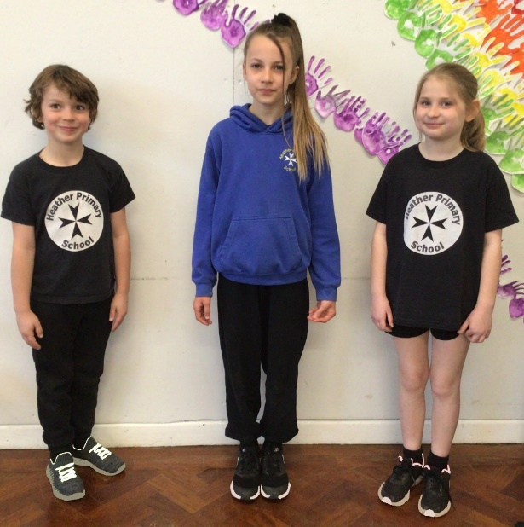
- Swimming Year 3-6 only – a full swimming costume for girls, trunks, swimming cap and a towel

Please note that football/rugby kits of famous and not so famous teams are not part of our school PE uniform.
It would be most helpful if these were put in a named drawstring bag, which your child could then hang on a peg to be kept safely at school for the whole week. This ensures that they have their PE kit in school on the right days.

School Bags
All children are bought a school book bag by our PTA when they start with us in Reception. This style bag is ideal for school as your child only needs to be able to bring in their school diary and reading books in them. Unfortunately, our cloakrooms do not have the space to accommodate large rucksacks/holdalls, so we would appreciate your support in encouraging your child to continue to use their book bag or a similar sized small bag, as they move up through school.

