Learning Project Week 7:
The UK
Please complete at least 3 of the tasks below during the week:
We love to see what you are doing on our private Facebook Page or Twitter Feed
www.facebook.com/groups/heatherprimaryschoolcolaville
@HeatherPrimary

Class: Rowling 2
Weekly Maths Tasks (1 per day) | Weekly Reading Tasks (1 per day)
My maths  Complete my maths tasks daily, there will now be one task set each day and progress will be monitored by your teacher every day.  Complete the following lessons year 2 maths on Fractions 1-5 on the national oak academy website as follows:  https://www.thenational.academy/  - To relate halves and quarters to division  - To identify the parts of a fraction  - To identify half of a shape  - To identify halves, quarters and thirds of a shape  - To identify fractions of a quantity and shape  Practice the following x tables  Easy 2x,5x,10x  Medium 3x,4x  Challenge yourselves 6x,8x | Use a text/leaflet you have at home or a website to research about a place in the UK. Write down 5 facts you have learnt. http://projectbritain.com/ is a really good website  https://www.bbc.co.uk/bitesize/articles/zhqr47h Bitesize Daily Book Club – Cake, by Sue Hendra and Paul Linnet. Extracts and Three Activities  https://www.bbc.co.uk/bitesize/articles/zncc92p Bitesize Daily Book Club – Attack of the Demon Dinner Ladies by Pamela Butchart. Extracts and Three Activities  Try map reading! Can you give directions from your house to a local destination?
Weekly Spelling Tasks (1 per day) | Weekly Writing Tasks (1 per day)
Weekly spellings:  The suffixes -less, -ly  - Learn these words:  badly,hopeless,penniless,happily,lovely, joyless,slowly,quickly,careless,fearless  - Once you have learnt your spellings, use them in some sentences. Try to use more than one word in each sentence. Mae your sentences extended and start each sentence with a different word.  - Practice reading and writing your year 2 common exception words.  - Practice any previous spellings recorded in your school diary. | Produce a leaflet / visitor guide for a place you have visited within the UK or a place you have researched from your reading activity.  Write a fact-file about the UK, thinking about:  *Population  *The 4 countries  *Capital Cities  *Major Rivers  *Natural Landmarks  *Traditions  https://www.thenational.academy/online-classroom/year-2#schedule Continue with Year 2 - WEEK 4 English lessons from the National Academy based on ‘The Firework Maker’s Daughter’
Learning Project – ongoing throughout the week.
Choose from the selection below.
This year would be a great year to re-discover out own country. This week’s project will focus on learning about the wonderful country we live in.

Geography:
Print out or trace an outline map of the UK. On the map shade in different colours the different countries – England, Scotland, Wales, Ireland. Then locate and write on the names of the following capital cities- London, Edinburgh, Cardiff, Belfast.
Now locate some other places on your map, these could be places where your family members live or places you have visited on holiday.

History:
In your local area, whilst out on a walk, photograph or draw a historical building, eg the church, the old village hall.
You could then research and find some facts about the building for example, when it was built, what it was/is used for, has it changed over time. Here are some examples.
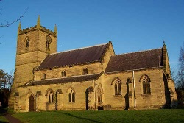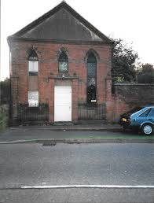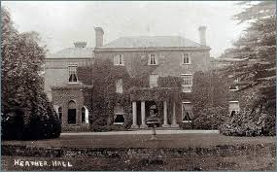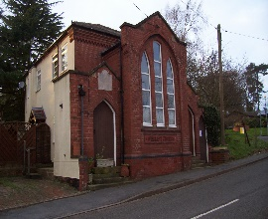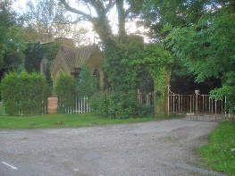
- 2. 3. 4. 5.
1.St Johns Church, Main Street, Heather
2.Heather Methodist Chapel, Pisca Lane, Heather
3.Heather Hall
4.Wesleyan Methodist Chapel, Newton Road, Heather
5. The Gatehouse, Swepstone Road, Heather

Music:
Listen to the national anthem, God Save The Queen’ can you learn the words to the first verse.
https://www.youtube.com/watch?v=ppIomb3r_3Q
When do people sing the national anthem? At what type of events do we sing the national anthem?

Art/DT:

https://www.tate.org.uk/kids - Explore the Tate Kids website for games & quizzes to play and lots of cool art and design projects to make.

Draw / Paint an iconic UK building or landmark. Maybe you could do a pencil drawing of Big Ben, paint/chalk a red London Bus, or do a colourful sketch of a Scottish loch or mountain.

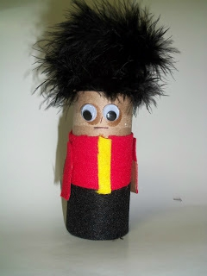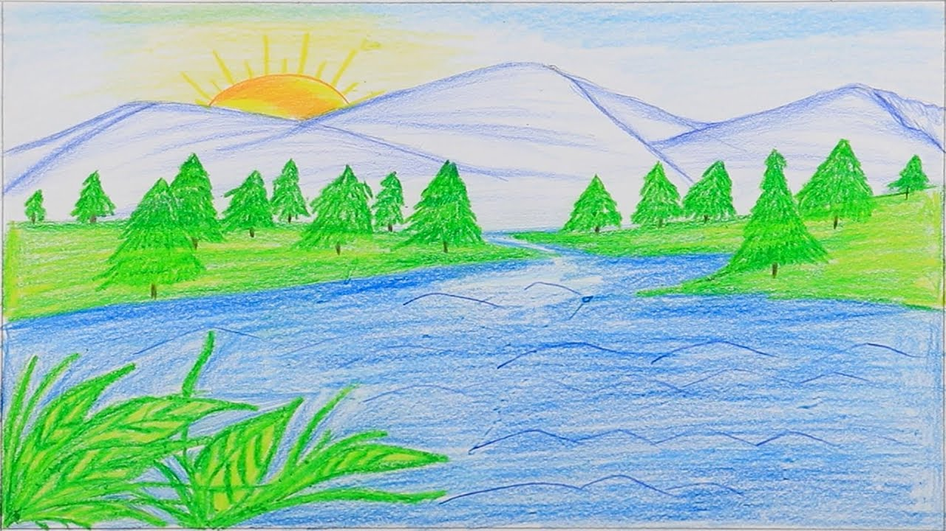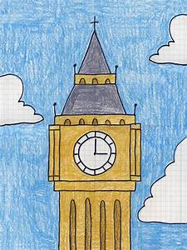

PE:
Complete the daily task from the NWLSSP power point (sent on Weduc daily).
Useful Websites:
https://www.natgeokids.com/uk/
http://projectbritain.com/

