Heather Primary School –
Homework Booklet

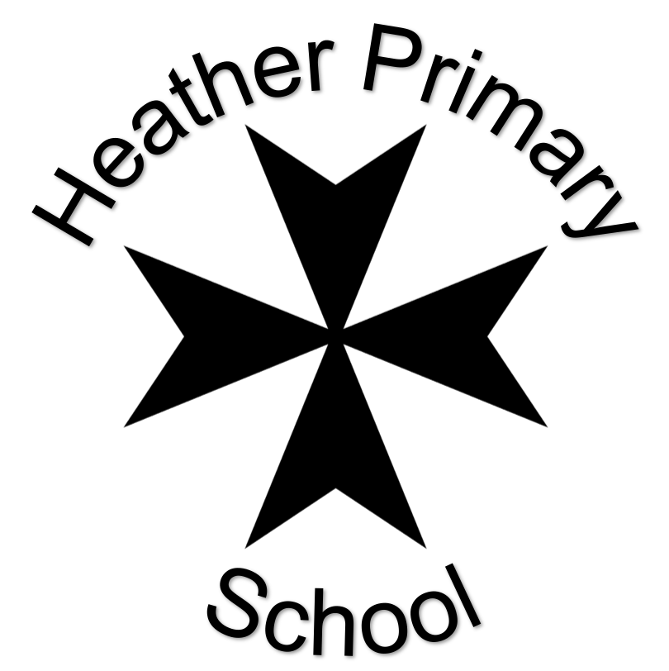

Summer 2022
Class: Caterpillar Class – EYFS
 | Task | Set | Due
 | Choose an activity from the list below. | Friday 29th April | Monday 9th May
 | Choose an activity from the list below. | Monday 16th May | Monday 6th June
 | Choose an activity from the list below. | Monday 13th June | Friday 27th June

Choices
Literacy
In our English lessons, we are learning the text Oliver’s Vegetables, which is based on the character making healthy choices and discovering that vegetables can we really tasty.  Can you create your own recipe using tasty vegetables?  You might want to create a recipe for a hearty stew or soup.  You could possibly create an imaginative pudding.  You might be really adventurous and create a three-course meal.  Show this by writing a recipe card or drawing pictures to label. | Write a diary to show all the fruit and vegetables you eat in one day. You could draw pictures or write a list. | Think about which vegetables you like to eat and why you like them. Write a sentence about your favourite vegetable. Draw a picture of your favourite vegetable.
Number
Practise writing numbers (up to 20) in your sandpit or soil at home with a small stick or shell. Read the numbers you write aloud to an adult. You may like to take a photograph and stick it in your book for us to see. | We are learning our numbers to 20 and beyond. Can you create a number line at home with the numbers from 0-20? You might want to do this outside on a washing line or on the patio with chalk or masking tape – be creative! | Practise your number bonds to 5.  You could show this using a whole part model or on a tens frame.
Other Subjects
Understanding the world  Research plants which only grow in particular climates around the world. | Understanding the world  Food from plants - Why are plants so important to humans? Research which foods we get from plants. Consider different parts of plants which can be eaten for example seeds - peas, bulbs - onions, leaves – cabbage and stems – celery. | Expressive art and design  Research the artist Giuseppe Archimboldo.  Create a portrait using real fruits and vegetables. Take a photograph and present it in your book.

