Learning Project Week 5: Beast Quest!
Class: Churchill Y3/4
Please complete at least 3 of the tasks below during the week:
We love to see what you are doing on our private Facebook Page or Twitter Feed: www.facebook.com/groups/heatherprimaryschoolcolaville
@HeatherPrimary
Maths Tasks | English Tasks
Daily  Participate in daily Maths lesson from government home learning website: https://www.thenational.academy/online-classroom/schedule/#schedule - lessons from week 3 please.  MyMaths – try to complete one task everyday  Weekly  Participate in Gareth Metcalfe’s Live Lesson once a week  Choose three 10 minute sessions (please use a range throughout the week) on either:  - Times Tables Rock Stars (Y4 please use Sound Check). Battle this week is Girls against Boys!  - Numbots  - Hit the Button (don’t forget doubles, halves and number bonds too)  Practise telling the time – you could even design a weekly learning timetable  Try to play a Maths-related game with your family for example:  - Uno  - Monopoly (be the banker)  - Lots of free Maths games on http://www.iseemaths.com/  If there is an area of Maths that you are struggling with try checking out https://mathantics.com/ – this website has lots of free Maths tutorials and you can select them by topic. |  | Daily  Participate in daily English lesson from the government learning website:  https://www.thenational.academy/online-classroom/schedule/#schedule - lessons from week 3 please.  Read for 20 minutes every day  Practise the spellings from your English lesson (above) daily throughout the week. These could be practised in the mud, sand, shaving foam etc  Weekly  If possible, try to be heard read aloud by an adult 3 times per week – this could be done as echo reading. Try to use expression.  Look up any new words from your reading book in a dictionary or use https://www.dictionary.com/ to look up the meaning. Try to write 3 different sentences using this new word.  Join read theory https://readtheory.org/ and try to do at least a 20 minute session per week.  Watch Newsround and discuss what is happening in the wider world  Practise your spelling on Spelling Shed

Learning Project – ongoing throughout the week.
Choose from the selection below.
Science
Find out all about mini-beasts in your own Beast Quest. You may want to find out about one particular area or include a summary of all. Think about how you might present your findings. Suggested areas of focus:
- Many insects are the target of predators. How do they protect themselves?
- Why are mini-beasts crucial to our survival?
- Find out about the different micro-habitats of mini-beasts. Carry out a study in your back garden/ yard or on a nature walk. What mini-beasts can you find in different areas (eg. under a long, in the grass, under a stone etc)?
- Find some photographs/ pictures of insects native to the UK and see if you can identify them on a nature walk. Can you use any classification grids or diagrams to classify the insects?
- What do different mini-beasts eat to survive?
Geography
Find out about countries where mini-beasts feature as part of the population’s diet. What type of insects does the population eat? Are there any nutritional benefits? What are the dangers of eating insects?

Compare minibeasts found in different landscapes – eg. desert, woodland, ocean. Do insects from a similar landscape have anything in common? Why do you think this might be?

Art
Get crafty and create a rock bug using large stones from a nature walk.
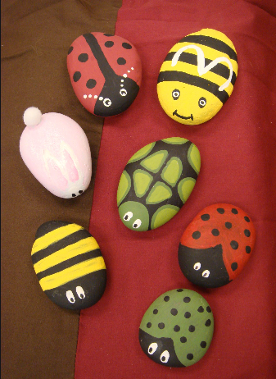
DT 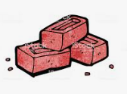
Design and make a bug hotel thinking about what you could include to attract different bugs.

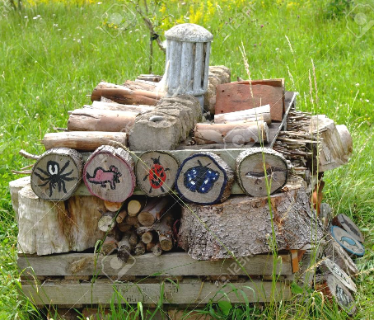

PE
Take part in the weekly PE Challenge from Mrs Michalowski.

