Work at Home Booklet
Donaldson Class
Maths | https://whiterosemaths.com/homelearning/ - are an amazing resource that we use in school all the time – they are producing free home learning pack – not all in place at the time of printing but will be soon  Play some of the Gareth Metcalfe Maths Games – free from his website: http://www.iseemaths.com/games-resources/
My Maths | 10/20 minutes daily Key Stage 1
Reading | Read daily and have diary signed (we have sent extra books home)  Listen to a story daily – either being read to or an audio story. If using a story from online – just have the audio playing not looking at the screen as well.  Some authors are offering a youtube story telling session – as we find any details we will let you know.
Phonics | Practise phonemes using letters and actions in your phonics book and tricky high frequency words using the flashcards. Please see below a copy of all phonemes and sounds in case you have misplaced yours.
Numbots | 15 minutes per day
Safe outdoor activities – see WEDUC for some activity sheets | https://www.woodlandtrust.org.uk/blog/2020/03/nature-detectives/  - Make a bird feeder  - Complete a 30 minute bird watch – list all the birds that come into your garden. Draw a picture of your favourite – find out as much as you can about them – make a top trump card for it!  - Make a boat our of leaf and twigs – can you get it to sail?  - Animal Home spotter sheet (see WEDUC) go for a wlak – whose home can you find?  - Build a bird nest – see challenge sheet  - Tiny Treasure hunt challenge  - Dandelion secret investigation  - Complete a spring hunt  - National Trust are opening their grounds for free – plenty of space at Calke Abbey to let of steam, climb a few trees etc
Indoor Activities | - Bake a cake – measure the ingredients yourself  - Do a jigsaw  - Learn some card games – YouTube will help -patience, clock patience, rummy, pontoon, whist  - Play dominoes, scrabble, monopoly
Music:  Charanga | - https://charanga.com/yumu/login?redirected_from_cmw=y  20/30 minutes
Spelling Lists and Word patterns | - Phase 2 tricky words to read and write, and phase 3 tricky words to read.
On going project | - Something linked to careers – Find pictures of key workers – do you know what jobs they do? Can you label part of their uniform?
Diary | - Keep a picture diary of what you do each day
Science | Look after your plant and complete a diary to document how your plant is changing as it grows.
PE | Joe Wicks, The Body Coach is doing daily PE lessons at 9am on his YouTube channel suitable for all children from EYFS right up to Secondary age children. Please follow the link below to subscribe to his channel:  https://www.youtube.com/channel/UCAxW1XT0iEJo0TYlRfn6rYQ  The Youth Sport Trust have offered a variety of free resources to help your child stay healthy and active. You can find resources using this link:  https://www.youthsporttrust.org/free-home-learning-resources?utm_campaign=11402914_Coronavirus%20message&utm_medium=email&utm_source=Youth%20Sport%20Trust&dm_i=1ZLF,6SEJM,UC5IC6,R5Y6F,1  Mr PE – a sports company based in Leicestershire are also offering free resources to help children stay fit and active. You can access their website using the following link: https://www.mr-pe.com/
ICT | Purple Mash  https://2simple.com/free-access  A brilliant IT resource, including a huge variety of activities to support spelling, grammar, maths, reading comprehension and a range of cross-curricular projects.  12 Museum Virtual Tours  https://www.msn.com/en-us/travel/travel-trivia/stuck-at-home-these-12-famous-museums-offer-virtual-tours-you-can-take-on-your-couch-video/ar-BB119nm6?li=BBnbfcL&fbclid=IwAR0_OBJH7lSyTN3ug_MsOeFnNgB1orTa9OBgilKJ7dhnwlVvHEsptuKkj1c  Free virtual tours of 12 famous museums  https://www.poissonrouge.com/free/classic/  Fun and educational online games and activities for children of all ages.  https://www.bbc.co.uk/teach/school-radio/nursery-rhymes-songs-index/zhwdgwx  Fun and educational online games

Phase 2 Phonics

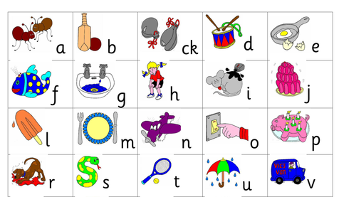

{hase 3 Phoics

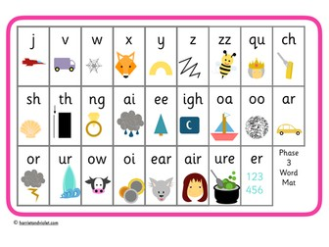

Phase 2 and 3 Tricky Words

Phase 2 and 3 Tricky Words:

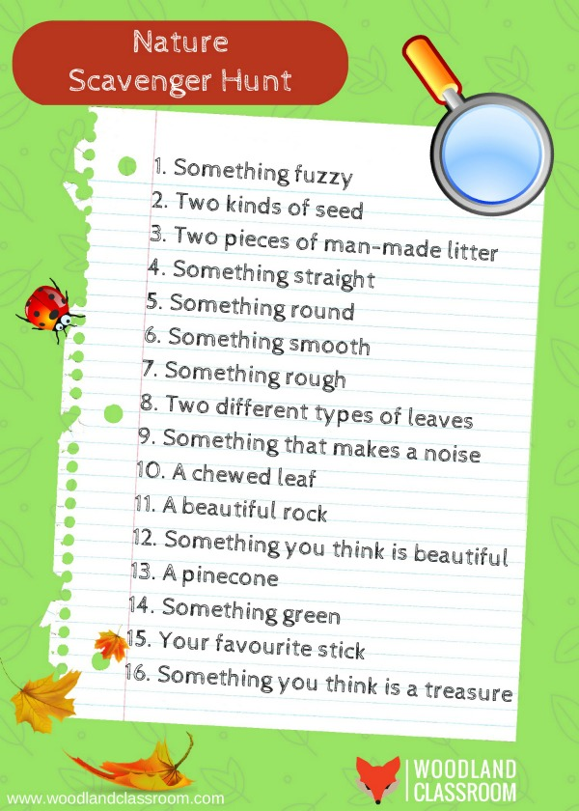

Suggested Daily Timetable – this is not meant to offend in the slightest. Some families may feel that a structure to the day may ease the time at home. You could always say – Mrs Clarkson said……..

Before 9.00am | Wake Up! | Eat breakfast, make your bed, get dressed, make sure PJs aren’t on the floor, brush your teeth for 2 mins!
9:00-10:00am | Morning Walk | Family walk with the dog (of you have one), inside https://www.bbc.co.uk/bitesize/subjects/z2hs34jif or Yoga on Youtube if raining or Joe Wicks Youtube
10:00-11:00am | Academic Time | NO ELECTRONICS  Soduko books, flash cards, word searches, school project, daily diary etc
11:00am-12:00pm | Creative Time | Lego. Magnatiles, drawing, crafting (Pintrest), sewing, knitting, play music, chalks outside, cook or bake etc.
12:00pm | Lunch
12:30pm | Chore Time | Create a list of 12 house hold jobs, Roll two dice and what ever number it makes, tackle household job first!
1:00pm-2:30pm | Quiet Time | Reading, Puzzles, Listen to an audio story
2:30pm-4:00pm | Academic Time | ELECTRONICS OK  My Maths, TT Rock Stars, Spelling Shed, Charanga Music
4:00pm-5:00pm | Afternoon Fresh Air | Bikes, Walk the dog, play outside – mini beast hunt, plant some seeds, create a tally chart of cars that go past, make mud pies
5:00pm-6:00pm | Dinner
6:00pm-6:45pm | Free TV time | Shower
7:00pm | Bed Time/Story time | All Kids -
7:15pm | Bed Time/story time | All Kids who follow the daily schedule!

